PYTHON
Programming Language
(Documentation)

- Abhinav Sai Vannam

PYTHON PROGRAMMING LANGUAGE

Content:
- Introduction
- What is Python
- Installation
- Variables
- Python Syntax
- Comments
- Data Types
- Operators
- Conditional Statements
- Loops
- Lists and List Methods
- String and String Methods
- Dictionary and Dictionary Methods
- Tuple and Tuple Methods
- Number and Number Methods
- Datetime Module
- Functions
- Modules
- Packages
- File Handling
- Error and Exception Handling
- OOPS
- Numpy
- Pandas
- Matplotlib
- Multi-Threading
- Regular Expressions
- OS Module
- Database Connection

PYTHON
What is Python?
Python is a popular programming language. It was created by Guido van Rossum, and released in 1991.
It is used for:
- web development (server-side),
- software development,
- mathematics,
- system scripting.
Python Features Python is a dynamic, high-level, free open source, and interpreted programming language. It supports object-oriented programming as well as procedural-oriented programming. In Python, we don’t need to declare the type of variable because it is a dynamically typed language. For example, x = 10 Here, x can be anything such as String, int, etc. In this article we will see what characteristics describe the python programming language.
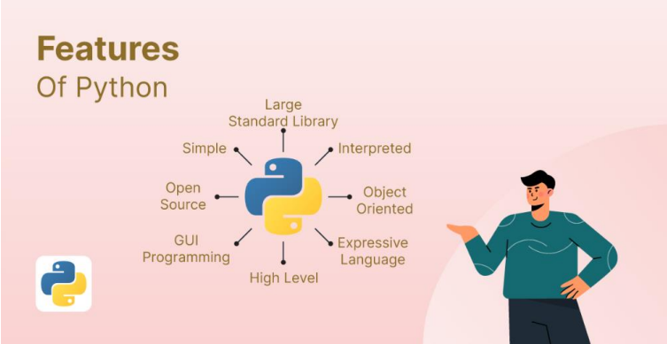
Features in Python
- Free and Open Source
- Easy to code Python is a high-level programming language.
- Easy to Read As you will see, learning Python is quite simple.
- Object-Oriented Language One of the key features of Python is Object-Oriented programming.
- Interpreted Language:

Why Python?
- Python works on different platforms (Windows, Mac, Linux, Raspberry Pi, etc).
- Python has a simple syntax similar to the English language.
- Python has syntax that allows developers to write programs with fewer lines than some other programming languages.
- Python runs on an interpreter system, meaning that code can be executed as soon as it is written. This means that prototyping can be very quick.
- Python can be treated in a procedural way, an object-oriented way or a functional way.

Python Syntax compared to other programming languages
- Python was designed for readability, and has some similarities to the English language with influence from mathematics.
- Python uses new lines to complete a command, as opposed to other programming languages which often use semicolons or parentheses.
- Python relies on indentation, using whitespace, to define scope; such as the scope of loops, functions and classes. Other programming languages often use curly-brackets for this purpose.

First Program:
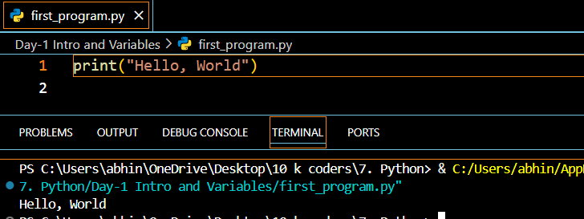
Python Installation:
https://www.tutorialspoint.com/how-to-install-python-in-windows

Python Variables
Python Variable is containers that store values. Python is not “statically typed”. We do not need to declare variables before using them or declare their type. A variable is created the moment we first assign a value to it. A Python variable is a name given to a memory location. It is the basic unit of storage in a program.
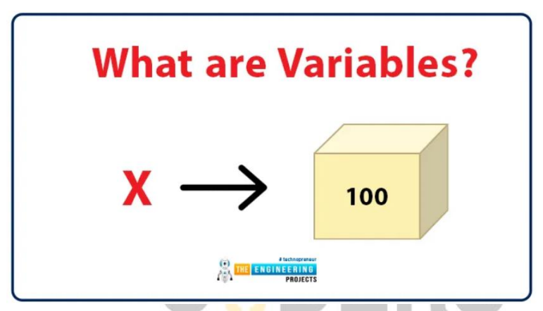

Example of Variable in Python
An Example of a Variable in Python is a representational name that serves as a pointer to an object. Once an object is assigned to a variable, it can be referred to by that name. In layman’s terms, we can say that Variable in Python is containers that store values.
var = "10KCoders"

Variables Assignment in Python
Here, we will define a variable in python. Here, clearly we have assigned a number, a floating point number, and a string to a variable such as age, salary, and name.
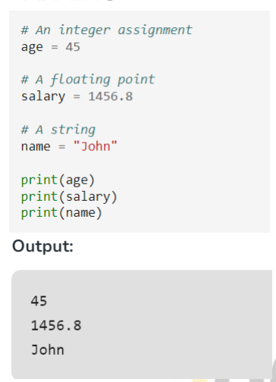

Declaration and Initialization of Variables
Let’s see how to declare a variable and how to define a variable and print the variable.
For example:
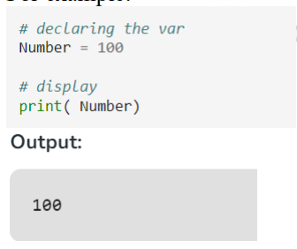
Redeclaring variables
in Python We can re-declare the Python variable once we have declared the variable and define variable in python already.

For example:
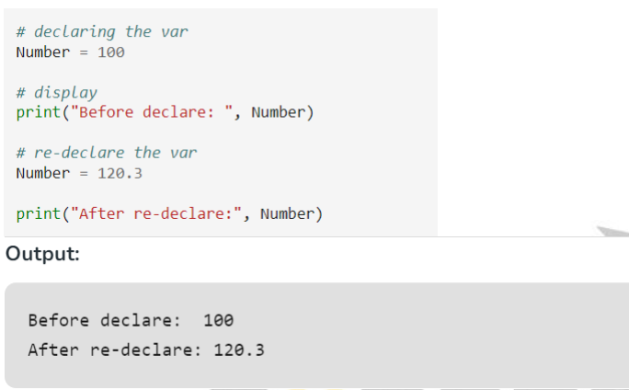
Python Assign Values to Multiple Variables Also,
Python allows assigning a single value to several variables simultaneously with “=” operators.
For example:
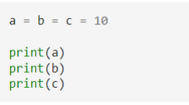
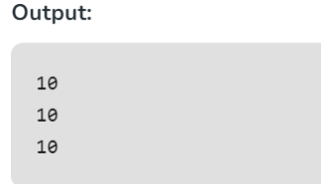
Assigning different values to multiple variables
Python allows adding different values in a single line with “,” operators.
For example
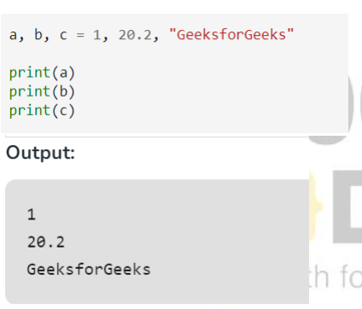
Python Syntax:
Python Indentation
- Indentation refers to the spaces at the beginning of a code line.
- Where in other programming languages the indentation in code is for readability only, the indentation in Python is very important.
- Python uses indentation to indicate a block of code.
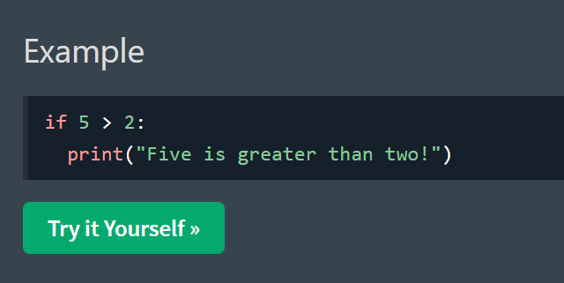

Python Comments
- Comments can be used to explain Python code.
- Comments can be used to make the code more readable.
- Comments can be used to prevent execution when testing code.

Creating a Comment
Comments starts with a #, and Python will ignore them:
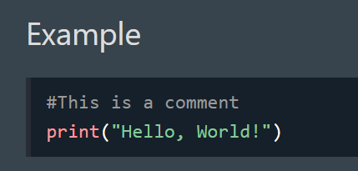
Multiline Comments
Python does not really have a syntax for multiline comments.
To add a multiline comment you could insert a # for each line:

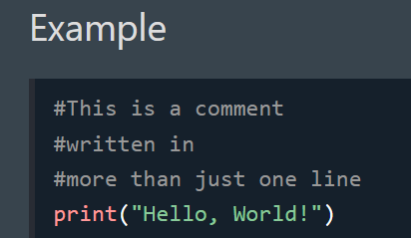

Python Data Types
Python Data types are the classification or categorization of data items. It represents the kind of value that tells what operations can be performed on a particular data. Since everything is an object in Python programming, Python data types are classes and variables are instances (objects) of these classes.
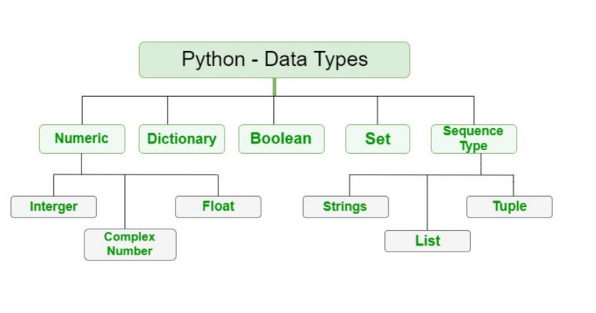
The following are the standard or built-in data types in Python:
- Numeric
- Sequence Type
- Boolean
- Set
- Dictionary

Numeric Data Types in Python
The numeric data type in Python represents the data that has a numeric value. A numeric value can be an integer, a floating number, or even a complex number.
Integers – This value is represented by int class. It contains positive or negative whole numbers (without fractions or decimals). In Python, there is no limit to how long an integer value can be.
Float – This value is represented by the float class. It is a real number with a floating-point representation.
Complex Numbers – A complex number is represented by a complex class. It is specified as (real part) + (imaginary part)j .
For example – 2+3j

Note – type() function is used to determine the type of Python data type.
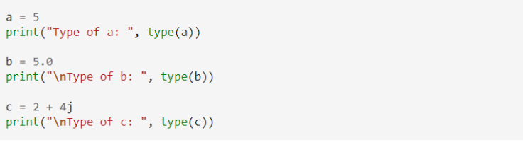
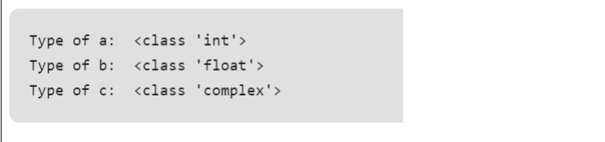
Sequence Data Types in Python
The sequence Data Type in Python is the ordered collection of similar or different Python data types. Sequences allow storing of multiple values in an organized and efficient fashion. There are several sequence data types of Python:
- Python String
- Python List
- Python Tuple

String Data Type
Strings in Python are arrays of bytes representing Unicode characters. A string is a collection of one or more characters put in a single quote, double-quote, or triple-quote.
Example: This Python code showcases various string creation methods. It uses single quotes, double quotes, and triple quotes to create strings with different content and includes a multiline string. The code also demonstrates printing the strings and checking their data types.
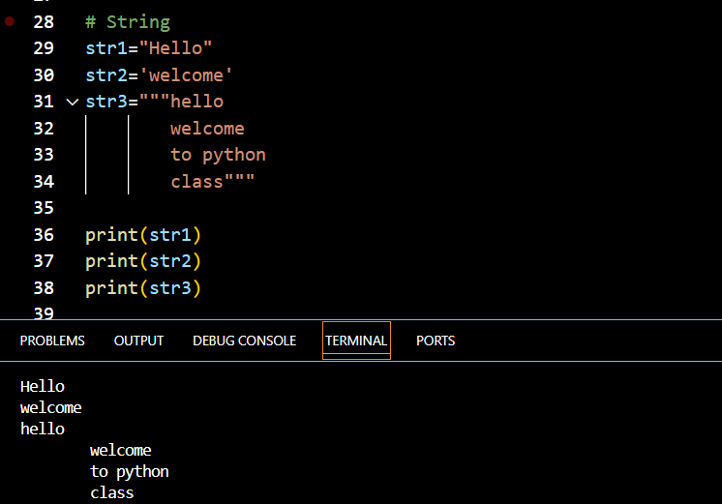

List Data Type
Lists are just like arrays, declared in other languages which is an ordered collection of data. It is very flexible as the items in a list do not need to be of the same type.
Creating a List in Python Lists in Python can be created by just placing the sequence inside the square brackets[].
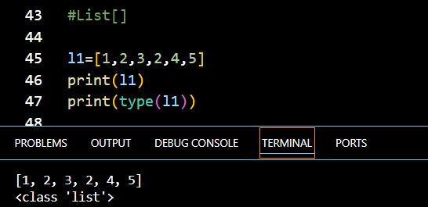
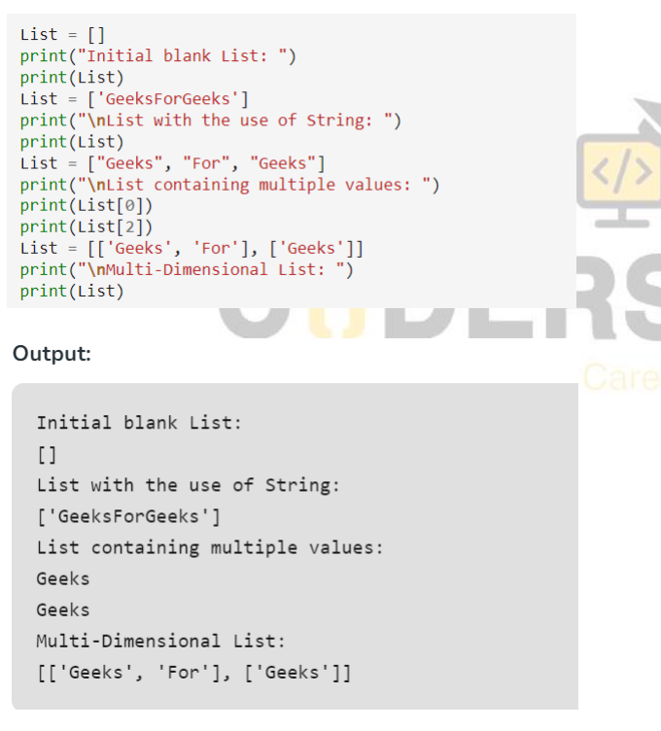
Tuple Data Type
Just like a list, a tuple is also an ordered collection of Python objects. The only difference between a tuple and a list is that tuples are immutable i.e. tuples cannot be modified after it is created. It is represented by a tuple class.
Creating a Tuple in Python
In Python Data Types, tuples are created by placing a sequence of values separated by a ‘comma’ with or without the use of parentheses for grouping the data sequence

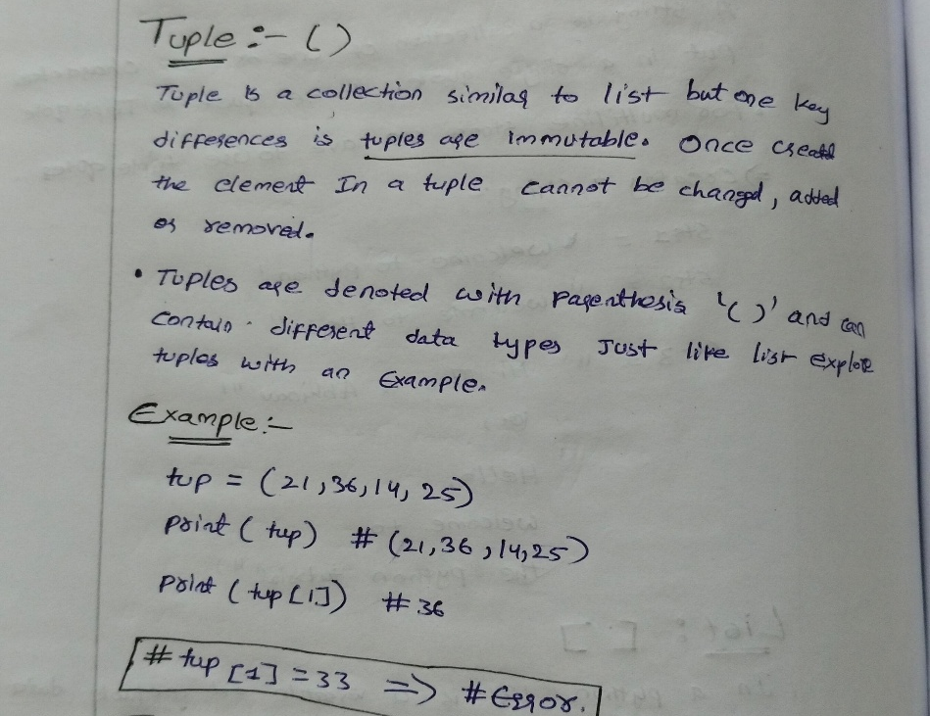
Boolean Data Type in Python
Python Data type with one of the two built-in values, True or False. Boolean objects that are equal to True are truthy (true), and those equal to False are falsy (false). However non-Boolean objects can be evaluated in a Boolean context as well and determined to be true or false. It is denoted by the class bool.
Note – True and False with capital ‘T’ and ‘F’ are valid booleans otherwise python will throw an error.
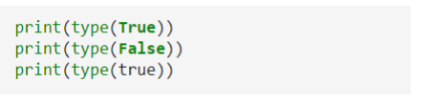
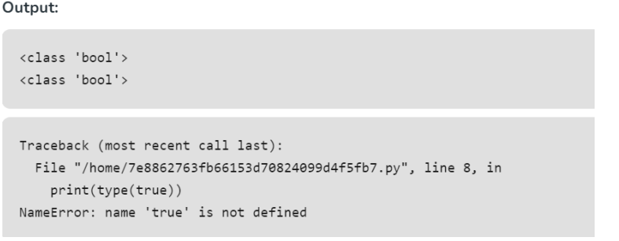
Set Data Type in Python
In Python Data Types, a Set is an unordered collection of data types that is iterable, mutable, and has no duplicate elements. The order of elements in a set is undefined though it may consist of various elements.
Create a Set in Python
Sets can be created by using the built-in set() function with an iterable object or a sequence by placing the sequence inside curly braces, separated by a ‘comma’. The type of elements in a set need not be the same, various mixed-up data type values can also be passed to the set.
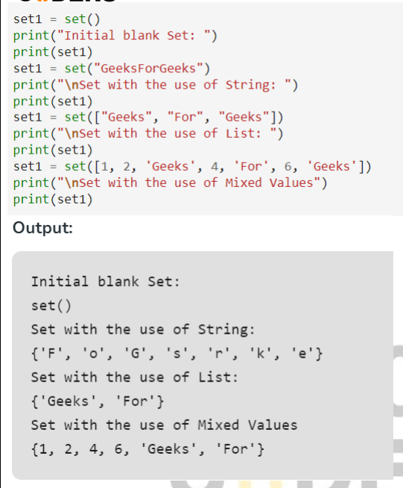
Dictionary Data Type in Python
A dictionary in Python is an unordered collection of data values, used to store data values like a map, unlike other Python Data Types that hold only a single value as an element, a Dictionary holds a key: value pair. Key-value is provided in the dictionary to make it more optimized. Each key-value pair in a Dictionary is separated by a colon : , whereas each key is separated by a ‘comma’
Create a Dictionary in Python
In Python, a Dictionary can be created by placing a sequence of elements within curly {} braces, separated by ‘comma’. Values in a dictionary can be of any datatype and can be duplicated, whereas keys can’t be repeated and must be immutable.
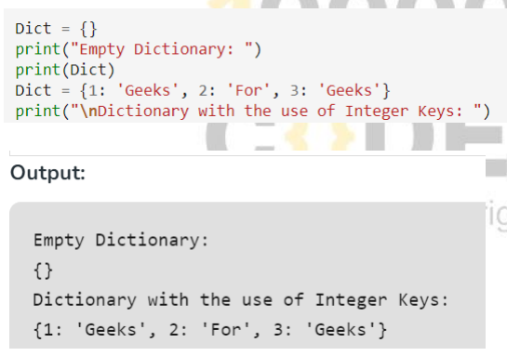

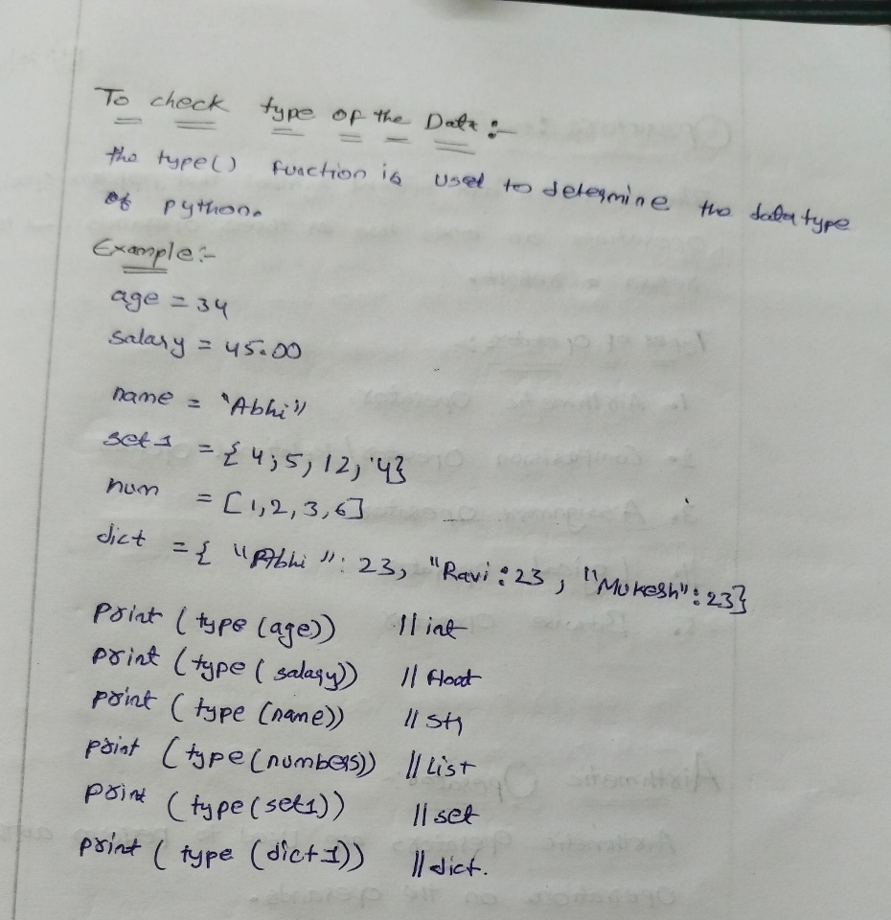

Operators
The operators are special symbols that perform specific operations on one, two or three operands and return a result.
Types of Operators
- Arithmetic Operators
- Comparison Operators / Relational Operators
- Assignment Operators
- Logical Operators
- Bitwise Operators

Arithmetic Operators
Arithmetic operators are used to perform arithmetic operations on the operands.
+ - * / % ** //

Assignment Operators
Used to assign a value to variables.
= += -= *= /= %= **= //= &=
Example:
x = 3
x **= 2
print(x)
Output:
9

Relational / Comparison Operators
- Used to compare values.
- They return a Boolean value: True or False.
Operators:
== > < != >= <=

Logical Operators
Logical operators return a Boolean value by evaluating Boolean expressions.
and
or
not

Logical AND
Input 1 | Input 2 | Output
True | True | True
True | False | False
False | True | False
False | False | False

Logical OR
Input 1 | Input 2 | Output
True | True | True
True | False | True
False | True | True
False | False | False

Logical NOT
Input | Output
True | False
False | True

Bitwise Operators
Bitwise operators are used to compare binary numbers.
AND (&)
The & operator compares each bit and sets it to 1 if both bits are 1; otherwise, it sets it to 0.
0 0 → 0
0 1 → 0
1 0 → 0
1 1 → 1
Example:
6 = 110
3 = 011
---
010
Therefore:
6 & 3
Output:
2
OR (|)
The | operator compares each bit and sets it to 1 if one or both bits are 1; otherwise, it sets it to 0.
0 0 → 0
0 1 → 1
1 0 → 1
1 1 → 1
XOR (^)
The ^ operator compares each bit and sets it to 1 if only one 1 is present. Otherwise, it sets it to 0.
0 0 → 0
0 1 → 1
1 0 → 1
1 1 → 0

NOT (~)
The ~ operator inverts each bit.
0 → 1
1 → 0
Example:
~3
Result:
-4
Left Shift (<<)
The << operator shifts the specified number of bits to the left.
Example:
3 << 2
Binary representation:
3 = 0011
After shifting 2 positions:
1100
Therefore:
3 << 2 = 12

Right Shift (>>)
The >> operator moves each bit the specified number of times to the right.
Example:
8 = 1000
Right shift by 2:
1000 >> 2 = 0010
Therefore:
8 >> 2 = 2

Conditional statements
If Statement:
The if statement is the most simple decision-making statement. It is used to decide whether a certain statement or block of statements will be executed or not.
Flowchart of If Statement Let’s look at the flow of code in the Python If statements
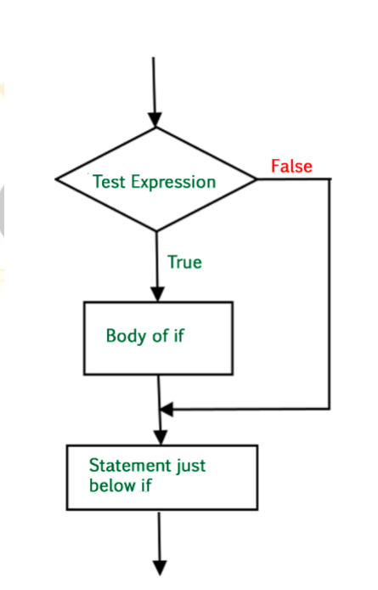
Syntax of If Statement:
if condition:
# Statements to execute if
# condition is true
Example:
# if statement example
if 10 > 5:
print("10 greater than 5")
print("Program ended")

Output:
10 greater than 5
Program ended

Python If Else Statement
The if statement alone tells us that if a condition is true it will execute a block of statements and if the condition is false it won’t. But if we want to do something else if the condition is false, we can use the else statement with the if statement Python to execute a block of code when the Python if condition is false
Flowchart of If Else Statement Let’s look at the flow of code in an if else Python statement.
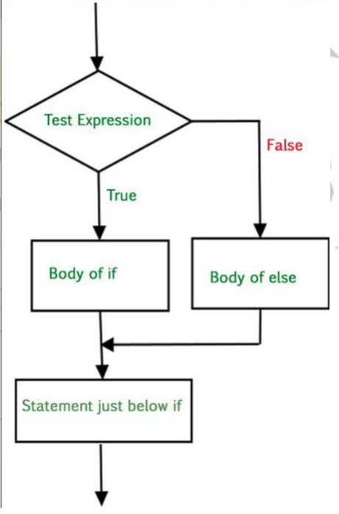
Syntax of Python If-Else:
if (condition):
# Executes this block if
# condition is true
else:
# Executes this block if
# condition is false
Example:
# if..else statement example
x = 3
if x == 4:
print("Yes")
else:
print("No")
Output: No

Python Nested If Statement
A nested if is an if statement that is the target of another if statement.
Nested if statements mean an if statement inside another if statement.
Basic Structure
if condition:
# Executes the condition if true

if condition:
# Executes the condition if true
Elif Statement
Here, a user can decide among multiple options. The if statements are executed from the top down.
Syntax
if condition:
statement

elif condition:
statement

elif condition:
statement

else:
statement
Note
If a statement cannot be empty, use the pass statement to avoid getting an error.
Example:
if condition:
pass
Short Hand If / Ternary Statement
Example:
num = 11

print("even") if num % 2 == 0 else print("odd")
The ternary statement can be used to write an if-else statement in a single line where only one statement is needed in both the if and else blocks.

LOOPS
For Loop
A for loop is used for iteration over a sequence, such as a list, tuple, dictionary, set, or string.
This is less like the for loop in other programming languages and works more like an iterator method.
Example – Loop Through a List
fruits = ["apple", "banana", "cherry"]

for x in fruits:
print(x)
Example – Loop Through a String
for x in "banana":
print(x)
Break
With the break statement, we can stop the loop before it has looped through all the items.
Example:
fruits = ["apple", "banana", "cherry"]

for x in fruits:
print(x)

if x == "banana":
break
Continue
continue can stop the current iteration of the loop and continue with the next iteration.
Example:
fruits = ["apple", "banana", "cherry"]

for x in fruits:
if x == "banana":
continue

print(x)

The range() Function
The range() function returns a sequence of numbers, starting from 0 by default, increments by 1 by default, and ends at a specified number.
Example 1
for x in range(6):
print(x)
Output:
0
1
2
3
4
5
Example 2
for x in range(2, 6):
print(x)
Output:
2
3
4
5
Example 3
for x in range(3, 30, 2):
print(x)
Here:
3 = Start
30 = End
2 = Increment
Nested Loops
- A nested loop is a loop inside a loop.
- The inner loop will be executed one time for each iteration of the outer loop.
Example
adj = ["red", "big", "tasty"]

fruits = ["apple", "banana", "cherry"]

for x in adj:
for y in fruits:
print(x, y)
While Loop
A while loop is used to execute a block of statements repeatedly until a given condition is satisfied.
When the condition becomes false, the line immediately after the loop in the program is executed.
Syntax
while expression:
statement(s)
Example
count = 0

while count < 3:
count = count + 1
print("Hello")
Nested For Loop Example
for i in range(1, 6):
for j in range(1, 11):
print(i, "x", j, "=", i * j)
Formatted String
Example:
name = "Abhi"

print(f"hello {name}")
Output:
hello Abhi
The {name} part is used inside the formatted string to insert the value of the variable.

Lists and List Methods
List
A list is an ordered collection of data and is mutable, which means its elements can be changed after the list is created.
Syntax
list_name = [value1, value2, value3]
Important Points
- A list is an ordered collection.
- Lists are mutable.
- A list can contain different types of data.
- List elements are accessed using indexes.
- The index starts from 0.
Example
ages = [19, 26, 29]

print(ages)
List with Different Data Types
student = ["name", 20, 75.5, [1, 2], True]

print(student)

2. Accessing List Elements
Accessing a Single Element by Index
numbers = [10, 20, 30, 40, 50]

print(numbers[0]) # 10
print(numbers[3]) # 40
Index Positions
10 20 30 40 50
0 1 2 3 4

3. Accessing Elements Using Negative Indexing
Negative indexing starts from the end of the list.
numbers = [10, 20, 30, 40, 50]

last_element = numbers[-1]

print(last_element) # 50
print(numbers[-2]) # 40
Negative Index Positions
10 20 30 40 50
-5 -4 -3 -2 -1

4. Iterating Over a List Using a for Loop
A for loop can be used to access each element of a list.
fruits = ["apple", "banana", "cherry", "date"]

for fruit in fruits:
print(fruit)
Output
apple
banana
cherry
date

5. Iterating Over a List Using a while Loop
A list can also be traversed using a while loop.
fruits = ["apple", "banana", "cherry", "date"]

index = 0

while index < len(fruits):
print(fruits[index])
index += 1
Here, len() returns the number of elements in the list.

List Methods
Python provides several built-in methods for working with lists.
The PDF covers the following list methods:
- append()
- copy()
- clear()
- count()
- extend()
- index()
- insert()
- pop()
- remove()
- reverse()
- sort()
- min()
- max()

6. append()
The append() method adds an element to the end of the list.
Syntax
list.append(element)
Example
numbers = [1, 2, 3]

numbers.append(4)

print(numbers)
Output
[1, 2, 3, 4]

7. copy()
The copy() method creates a shallow copy of the list.
Example
numbers = [1, 2, 3]

num_copy = numbers.copy()

print(num_copy)
Output
[1, 2, 3]

8. clear()
The clear() method removes all elements from the list.
Example
numbers = [1, 2, 3]

numbers.clear()

print(numbers)
Output
[]

9. count()
The count() method returns the number of occurrences of a specified element in the list.
Example
numbers = [1, 2, 2, 3]

count_of_two = numbers.count(2)

print(count_of_two)
Output
2

10. extend()
The extend() method adds elements of an iterable, such as another list, to the end of the current list.
Example
numbers = [1, 2, 3]

numbers.extend([4, 5])

print(numbers)
Output
[1, 2, 3, 4, 5]

11. index()
The index() method returns the index of the first occurrence of a specified element.
Example
numbers = [1, 2, 3, 2]

index_of_two = numbers.index(2)

print(index_of_two)
Output
1
The first 2 occurs at index 1.

12. insert()
The insert() method inserts an element at a specific position in the list.
Syntax
list.insert(index, element)
Example
numbers = [1, 2, 3]

numbers.insert(2, 4)

print(numbers)
Output
[1, 2, 4, 3]
Here, 4 is inserted at index 2.

13. pop()
The pop() method removes and returns an element at the specified index.
If no index is specified, it removes and returns the last element.
Example
numbers = [1, 2, 3]

last_element = numbers.pop()

print(last_element)
print(numbers)
Output
3
[1, 2]
Removing an Element at a Specific Index
numbers = [1, 2, 3, 4]

element = numbers.pop(1)

print(element)
print(numbers)
Output:
2
[1, 3, 4]

14. remove()
The remove() method removes the first occurrence of a specified element.
Example
numbers = [1, 2, 3, 2]

numbers.remove(2)

print(numbers)
Output
[1, 3, 2]
Only the first occurrence of 2 is removed.

15. reverse()
The reverse() method reverses the elements of the list.
Example
numbers = [1, 2, 3]

numbers.reverse()

print(numbers)
Output
[3, 2, 1]

16. sort()
The sort() method sorts the list in ascending order by default.
Ascending Order
numbers = [3, 1, 4, 2]

numbers.sort()

print(numbers)
Output
[1, 2, 3, 4]
Descending Order
Use reverse=True.
numbers = [3, 1, 4, 2]

numbers.sort(reverse=True)

print(numbers)
Output
[4, 3, 2, 1]

17. min()
The min() function returns the smallest element in the list.
Example
numbers = [3, 1, 4, 2]

minimum = min(numbers)

print(minimum)
Output
1

18. max()
The max() function returns the largest element in the list.
Example
numbers = [3, 1, 4, 2]

maximum = max(numbers)

print(maximum)
Output
4

19. List Comprehension
List comprehension provides a concise way to create lists in Python.
It is a shorthand for looping through an iterable and applying an expression to each item.
Syntax
new_list = [expression for item in iterable]

Example 1 – Create a List of Squares
squares = [x**2 for x in range(5)]

print(squares)
Output
[0, 1, 4, 9, 16]

Example 2 – Create a List of Even Numbers
even = [x for x in range(10) if x % 2 == 0]

print(even)
Output
[0, 2, 4, 6, 8]

20. Nested Lists
A nested list is a list that contains other lists as its elements.
Example
matrix = [
[1, 2, 3],
[4, 5, 6],
[7, 8, 9]
]
Accessing an Element
Nested-list elements can be accessed using multiple indexes.
print(matrix[1][2])
Output
6
Here:
matrix[1] → [4, 5, 6]
matrix[1][2] → 6

21. Iterating Through a Nested List
A nested list can be traversed using nested for loops.
matrix = [
[1, 2, 3],
[4, 5, 6],
[7, 8, 9]
]

for row in matrix:
for element in row:
print(element, end=" ")

print()
Output
1 2 3
4 5 6
7 8 9

String and string methods:
String
A string is a collection of one or more characters.
Strings can be written using:
- Single quotes ' '
- Double quotes " "
- Triple quotes ''' ''' or """ """
For multiline strings, triple quotes are used.
Example
str1 = "Abhi"

print(str1)
Multiline String
message = """
This is a
multiline string
"""

print(message)
The uploaded PDF introduces strings and then covers common string methods with examples.

2. Creating a String
A string can be created by assigning text to a variable.
str1 = "Abhi"

print(str1)

String Methods
The PDF covers the following string methods:
- lower()
- capitalize()
- upper()
- title()
- strip()
- lstrip()
- rstrip()
- replace()
- split()
- join()
- find()
- index()
- startswith()
- endswith()
- isdigit()
- isalpha()
- isalnum()
- isnumeric()
- isspace()
- swapcase()
- zfill()
- rjust()
- ljust()
- center()

3. lower()
The lower() method converts a string into lowercase.
Example
string1 = "Python is Great"

print(string1.lower())
Output
python is great

4. capitalize()
The capitalize() method converts the first character of the string to uppercase and the remaining characters to lowercase.
Example
string = "python is great"

print(string.capitalize())
Output
Python is great

5. upper()
The upper() method converts a string into uppercase.
Example
str1 = "Python is great"

print(str1.upper())
Output
PYTHON IS GREAT

6. title()
The title() method converts the first character of each word to uppercase.
Example
str1 = "python is great"

print(str1.title())
Output
Python Is Great

7. strip()
The strip() method returns a trimmed version of the string by removing spaces from both the beginning and the end.
Example
string = " Python is great "

print(string.strip())
Output
Python is great

8. lstrip()
The lstrip() method removes whitespace from the left side of the string.
Example
str1 = " Python is great"

print(str1.lstrip())
Output
Python is great

9. rstrip()
The rstrip() method removes whitespace from the right side of the string.
Example
str1 = "Python is great "

print(str1.rstrip())
Output
Python is great

10. replace()
The replace() method returns a string where a specified value is replaced with another specified value.
Syntax
string.replace(old, new)
Example
name = "abhi"

print(name.replace("a", "A"))
Output
Abhi

11. split()
The split() method splits a string at the specified separator and returns a list.
Example
string = "This is a string"

print(string.split(" "))
Output
['This', 'is', 'a', 'string']
To find the number of elements:
print(len(string.split(" ")))

12. join()
The join() method joins the elements of an iterable into a string.
Example
string = "This is a string"

print("-".join(string.split(" ")))
Output
This-is-a-string

13. find()
The find() method searches the string for a specified value and returns the position where it is found.
It returns the position of the first occurrence.
Example
string = "This is a string"

print(string.find("is"))
Output
2
The first "is" starts at index 2.

14. index()
The index() method searches the string for a specified value and returns the position where it is found.
Example
string = "String"

print(string.index("S"))
Output
0

15. startswith()
The startswith() method returns True if the string starts with the specified value.
Example
text = "Hello, welcome to my world"

x = text.startswith("Hello")

print(x)
Output
True

16. endswith()
The endswith() method returns True if the string ends with the specified value.
Example
name = "Abhi"

print(name.endswith("i"))
Output
True

17. isdigit()
The isdigit() method returns True if all characters in the string are digits.
Example
password = "secret_123"

for i in password:
if i.isdigit():
print("valid", i)
For example:
text = "12345"

print(text.isdigit())
Output:
True

18. isalpha()
The isalpha() method returns True if all characters in the string are alphabet letters (a-z).
Example
password = "secret"

for i in password:
if i.isalpha():
print("valid", i)
Another example:
text = "Python"

print(text.isalpha())
Output:
True

19. isalnum()
The isalnum() method returns True if all characters are a combination of alphabetic and numeric characters.
Example
text = "12345abc"

print(text.isalnum())
Output
True
A string containing spaces or special characters will return False.

20. isnumeric()
The isnumeric() method checks whether all characters in the string are numeric.
Example
text = "12345"

print(text.isnumeric())
Output
True

21. isspace()
The isspace() method returns True if all characters in the string are whitespace characters.
Example
text = " "

x = text.isspace()

print(x)
Output
True

22. swapcase()
The swapcase() method converts:
- Lowercase characters → Uppercase
- Uppercase characters → Lowercase
Example
name = "Abhi"

print(name.swapcase())
Output
aBHI

23. zfill()
The zfill() method fills the string with zeros at the beginning until it reaches the specified width.
Example
text = "50"

x = text.zfill(10)

print(x)
Output
0000000050

24. rjust()
The rjust() method returns a right-justified version of a string.
Example
text = "banana"

x = text.rjust(20)

print(x)
The string is shifted toward the right within a field of width 20.

25. ljust()
The ljust() method returns a left-justified version of a string.
Example
text = "banana"

x = text.ljust(10)

print(x)
The string is positioned toward the left within a field of width 10.

26. center()
The center() method returns a centered version of a string.
Example
text = "banana"

x = text.center(10)

print(x)
Output
banana
The string is positioned in the center of the specified width.

27. Example – Character-by-Character String Processing
The PDF also contains an example where a string is processed character by character.
string = "Python"

res = ""

for i in string:
if i >= "i":
res = res + i.lower()
else:
res = res + i.upper()

print(res)
This example demonstrates how string methods such as upper() and lower() can be used inside a for loop to process individual characters.

Dictionary
A dictionary is a collection that stores data in key-value pairs.
Important Points
- Dictionary elements are stored as key-value pairs.
- Dictionaries are enclosed in { } curly braces.
- Keys should be unique.
- The notes describe dictionary keys as strings.
- A dictionary can store multiple data types.
- Dictionaries are ordered and changeable.
- Duplicate keys are not allowed.
Example
thisdict = {
"brand": "Ford",
"model": "Mustang",
"year": 1964
}

print(thisdict)

2. Dictionary Characteristics
Ordered
Dictionary items maintain their order.
Changeable
Dictionary values can be changed after the dictionary is created.
Example:
thisdict["year"] = 1965
No Duplicate Keys
Dictionary keys should not be duplicated. If the same key is assigned again, the previous value is replaced.

3. Dictionary Length
The len() function returns the number of items in a dictionary.
Example
thisdict = {
"brand": "Ford",
"model": "Mustang",
"year": 1964
}

print(len(thisdict))
Output
3

4. Accessing Dictionary Items
Dictionary values can be accessed using their keys.
Using Square Brackets
thisdict = {
"brand": "Ford",
"model": "Mustang",
"year": 1964
}

x = thisdict["model"]

print(x)
Output
Mustang
Using get()
The get() method can also be used to access a value.
x = thisdict.get("model")

print(x)
Output
Mustang

5. keys()
The keys() method returns a list-like view containing the keys of the dictionary.
Example
x = thisdict.keys()

print(x)
The keys are:
brand
model
year

6. values()
The values() method returns a view containing all the values in the dictionary.
Example
x = thisdict.values()

print(x)
Example values:
Ford
Mustang
1964

7. items()
The items() method returns each dictionary item as a tuple containing the key and value.
Example
x = thisdict.items()

print(x)
Conceptually, the result contains:
("brand", "Ford")
("model", "Mustang")
("year", 1964)

8. Updating a Dictionary
The update() method updates the dictionary with items from the given argument.
Example
thisdict = {
"brand": "Ford",
"model": "Mustang",
"year": 1964
}

thisdict.update({"year": 2020})

print(thisdict)
The value of "year" is updated.

9. Adding Items to a Dictionary
A new key-value pair can be added by assigning a value to a new key.
Example
thisdict["color"] = "Red"

print(thisdict)
The dictionary now contains:
brand → Ford
model → Mustang
year → 1964
color → Red

10. Removing Items from a Dictionary
There are several methods for removing items from a dictionary.
Using pop()
The pop() method removes the item with the specified key.
thisdict.pop("model")

print(thisdict)

Using popitem()
The popitem() method removes the last inserted item.
thisdict.popitem()

print(thisdict)

Using del
The del statement can remove a specific item.
del thisdict["model"]

Deleting the Entire Dictionary
del thisdict
This deletes the dictionary completely.

11. clear()
The clear() method empties the dictionary.
Example
thisdict.clear()

print(thisdict)
Output
{}

12. Looping Through a Dictionary
A dictionary can be traversed using a for loop.
Loop Through Keys
for x in thisdict:
print(x)
This prints the dictionary keys.
Loop Through Values
for x in thisdict:
print(thisdict[x])
This prints the values.

Tuple
1. What is a Tuple?
A tuple is an ordered collection of elements.
The main difference between a list and a tuple is that a tuple is immutable.
Immutable means that once a tuple is created, its elements cannot be changed.
Example
tup1 = (2, "Hello", "Python")

print(tup1)
Output:
(2, 'Hello', 'Python')

2. Characteristics of Tuple
A tuple has the following characteristics:
- Ordered – Elements maintain their position.
- Immutable – Elements cannot be changed.
- Allows duplicates – The same value can appear multiple times.
- Supports indexing.
- Supports slicing.
- Can contain different data types.
Example:
student = ("Abhinav", 24, 85.5, True)

print(student)

3. Creating a Tuple
Normal Tuple
t1 = (1, 2, 3, 4)

print(t1)
Tuple with Different Data Types
t1 = (10, "Python", 3.14, True)

print(t1)
Single-Element Tuple
A comma is required for a single-element tuple.
t1 = (10,)

print(type(t1))
Without the comma:
t1 = (10)

print(type(t1))
This is an integer, not a tuple.

4. Accessing Tuple Elements
Tuple elements are accessed using indexes.
The index starts from 0.
lang = ("Python", "C", "C++")

print(lang[0])
print(lang[2])
Output:
Python
C++
Index Positions
Python C C++
0 1 2

5. Negative Indexing
Negative indexes start from the end.
lang = ("Python", "C", "C++")

print(lang[-1])
print(lang[-2])
Output:
C++
C

6. Tuple Cannot Be Modified
Tuples are immutable.
Therefore, this produces an error:
lang = ("Python", "C", "C++")

lang[2] = "Java"
You cannot directly change an existing tuple element.

7. Looping Through a Tuple
A for loop can be used to access every element.
fruits = ("apple", "banana", "orange")

for fruit in fruits:
print(fruit)
Output:
apple
banana
orange

8. Tuple Methods
Python tuples have two main built-in methods:
- count()
- index()

9. count()
The count() method returns the number of times a specified value occurs in a tuple.
Syntax
tuple.count(value)
Example
vowels = ("a", "e", "i", "o", "i", "u")

print(vowels.count("i"))
Output:
2
Because "i" occurs two times.

10. index()
The index() method returns the position of the first occurrence of a specified value.
Example
vowels = ("a", "e", "i", "o", "i", "u")

print(vowels.index("e"))
Output:
1
The first "e" is at index 1.

11. Tuple Operations
Apart from tuple methods, Python provides several operations and built-in functions that can be used with tuples.

11.1 max()
Returns the largest value.
numbers = (2, 3, 4, 5, 7, 8, 9)

print(max(numbers))
Output:
9

11.2 min()
Returns the smallest value.
numbers = (2, 3, 4, 5, 7, 8, 9)

print(min(numbers))
Output:
2

11.3 sum()
Returns the sum of numeric elements.
numbers = (2, 10, 8, 3, 7)

print(sum(numbers))
Output:
30

11.4 len()
Returns the number of elements.
numbers = (10, 20, 30, 40)

print(len(numbers))
Output:
4

12. Converting Tuple to List
The list() function converts a tuple into a list.
numbers = (1, 22, 2, 232.33)

print(list(numbers))
Output:
[1, 22, 2, 232.33]
This is useful when you need to modify the data.

13. Tuple Concatenation
Two tuples can be joined using the + operator.
t1 = (1, 2, 3)
t2 = (4, 5, 6)

print(t1 + t2)
Output:
(1, 2, 3, 4, 5, 6)

14. Adding Corresponding Tuple Elements
The zip() function can be used to combine corresponding elements.
t1 = (1, 2, 3)
t2 = (4, 5, 6)

new = []

for i, j in zip(t1, t2):
new.append(i + j)

print(tuple(new))
Output:
(5, 7, 9)
Explanation:
1 + 4 = 5
2 + 5 = 7
3 + 6 = 9

15. Tuple Repetition
The * operator can repeat a tuple multiple times.
d = (1, 2, 3)

print(d * 3)
Output:
(1, 2, 3, 1, 2, 3, 1, 2, 3)

16. Membership Operation
The in and not in operators check whether an element exists in a tuple.
d = (2, 3, 4, 5, 6, 6, 7, 7, 87, 88, 8)

print(22 in d)
print(22 not in d)
Output:
False
True

17. Identity Operation
The is and is not operators can check whether two variables refer to the same object.
Example:
t1 = (1, 2, 3)
t2 = (1, 2, 3, 5, 35, 34)

print(t1 is not t2)
Output:
True

18. Iterating Through a Tuple
We can use a for loop to access each element.
d = (1, 2, 3, 35, 4, 6, 7, 8)

for i in d:
print(i)
Output:
1
2
3
35
4
6
7
8

19. Nested Tuple
A nested tuple is a tuple containing other tuples.
nested = (
(1, 2, 3),
(4, 5, 6),
(7, 8, 9)
)

20. Accessing Nested Tuple
Use multiple indexes.
nested = (
(1, 2, 3),
(4, 5, 6),
(7, 8, 9)
)

print(nested[0][0])
Output:
1
Explanation:
nested[0] → (1, 2, 3)

nested[0][0] → 1

21. Searching in a Nested Tuple
We can search for a number using nested loops.
matrix = (
(1, 2, 3),
(4, 5, 6),
(2, 8, 9)
)

num = 7
exists = False

for i in matrix:
for j in i:
if j == num:
exists = True

if exists:
print("True")
else:
print("False")
Output:
False
Because 7 is not present.

Sets
Based on your uploaded Python Sets document.
1. What is a Set?
A set is an unordered collection of unique elements.
Main points
- Sets are unordered.
- Sets do not allow duplicate values.
- Sets are mutable, so we can add or remove elements.
- Sets do not support indexing or slicing.
- Sets are written using { }.
- Sets are useful for mathematical operations like union, intersection, difference, and symmetric difference.
Example
numbers = {10, 20, 30, 40}

print(numbers)

2. Creating a Set
numbers = {1, 2, 3}
print(numbers)
A set can also contain different data types:
my_set = {1, "Hello", (1, 2, 3)}

print(my_set)

3. Empty Set
This is important:
a = {}
{} creates an empty dictionary, not a set.
To create an empty set:
a = set()

print(type(a))
Output:
<class 'set'>

4. Adding Elements
add()
Adds one element to a set.
numbers = {1, 2}

numbers.add(3)

print(numbers)
Output:
{1, 2, 3}

update()
Adds multiple elements.
numbers = {1, 2}

numbers.update([3, 4, 5])

print(numbers)
Output:
{1, 2, 3, 4, 5}
update() can take a list, tuple, string, or another set.

5. Removing Elements
remove()
Removes a specified element.
numbers = {1, 2, 3}

numbers.remove(2)

print(numbers)
Output:
{1, 3}
If the element doesn't exist, remove() gives an error.

discard()
Also removes an element, but does not give an error if the element doesn't exist.
numbers = {1, 2, 3}

numbers.discard(5)

print(numbers)
No error occurs.
Easy Difference
remove() → Error if element is not present
discard() → No error if element is not present

pop()
Removes and returns an element from the set.
numbers = {1, 2, 3}

x = numbers.pop()

print(x)
print(numbers)
Since a set is unordered, we cannot predict which element will be removed.

clear()
Removes all elements.
numbers = {1, 2, 3}

numbers.clear()

print(numbers)
Output:
set()

6. Set Operations
Suppose:
A = {1, 2, 3, 4, 5}
B = {4, 5, 6, 7, 8}
There are four important set operations:
- Union
- Intersection
- Difference
- Symmetric Difference

7. Union
Union means all elements from both sets.
Operator: |
A = {1, 2, 3, 4, 5}
B = {4, 5, 6, 7, 8}

print(A | B)
Output:
{1, 2, 3, 4, 5, 6, 7, 8}
Method
print(A.union(B))
Remember
A | B → Everything from A and B

8. Intersection
Intersection means common elements in both sets.
Operator: &
A = {1, 2, 3, 4, 5}
B = {4, 5, 6, 7, 8}

print(A & B)
Output:
{4, 5}
Method
print(A.intersection(B))
Remember
A & B → Common elements
The uploaded document illustrates this with a Venn diagram showing the common middle portion of the two sets.

9. Difference
Difference means elements present in the first set but not in the second.
Operator: -
A = {1, 2, 3, 4, 5}
B = {4, 5, 6, 7, 8}

print(A - B)
Output:
{1, 2, 3}
Method
print(A.difference(B))
Reverse Difference
print(B - A)
Output:
{6, 7, 8}
Remember
A - B → A only
B - A → B only

10. Symmetric Difference
Symmetric difference means elements that are in A or B, but not in both.
Operator: ^
A = {1, 2, 3, 4, 5}
B = {4, 5, 6, 7, 8}

print(A ^ B)
Output:
{1, 2, 3, 6, 7, 8}
Method
print(A.symmetric_difference(B))
Remember
A ^ B → Non-common elements
The document's Venn diagram shows the two outer portions while excluding the intersection.

11. Set Membership
Use in to check whether an element exists in a set.
my_set = set("apple")

print("a" in my_set)
Output:
True
Use not in to check that an element does not exist.
print("x" not in my_set)
Output:
True

12. Loop Through a Set
We can use a for loop to access each element.
my_set = set("apple")

for letter in my_set:
print(letter)
Remember: because sets are unordered, do not depend on the order of output.

13. Important Set Methods
Method | Simple Meaning
add() | Add one element
update() | Add multiple elements
remove() | Remove an element; error if absent
discard() | Remove an element; no error if absent
pop() | Remove and return an arbitrary element
clear() | Remove all elements
union() | Combine two sets
intersection() | Find common elements
difference() | Find elements only in first set
symmetric_difference() | Find non-common elements

Number and Number methods:
Number and Number Methods in Python – Simple Notes
Based on your uploaded Number and Number Methods notes.
1. Numbers in Python
Variables of numeric types are created when we assign a numerical value to them.
Python mainly has three numeric types:
- int – Integer
- float – Floating-point number
- complex – Complex number
Example
x = 10 # int
y = 2.8 # float
z = 2 + 3j # complex
We can check the type using:
print(type(x))
print(type(y))
print(type(z))

2. abs()
abs() returns the absolute value of a number.
Example
x = -5

print(abs(x))
Output:
5
For a complex number, abs() returns its magnitude.
x = 3 + 5j

print(abs(x))

3. round()
round() rounds a number to the nearest value.
Example
print(round(5.7))
Output:
6
print(round(2.3))
Output:
2
print(round(6.5))
The notes demonstrate round() with decimal values to show rounding to the nearest number.

4. pow()
pow() is used to find the power of a number.
Syntax
pow(base, exponent)
Example
print(pow(2, 3))
Output:
8
Because:
2³ = 2 × 2 × 2 = 8

5. divmod()
divmod() returns two values:
- Quotient
- Remainder
Syntax
divmod(a, b)
Example
print(divmod(3, 3))
Output:
(1, 0)
Another example:
print(divmod(5, 3))
Output:
(1, 2)
Here:
Quotient = 1
Remainder = 2

6. int()
int() converts a value into an integer.
Example
x = int(3.5)

print(x)
Output:
3
Another example:
x = int("25")

print(x)
Output:
25

7. float()
float() converts a value into a floating-point number.
Example
x = float(3)

print(x)
Output:
3.0
Another example:
x = float("3.5")

print(x)
Output:
3.5

8. complex()
complex() creates a complex number using a real part and an imaginary part.
Example
x = complex(3, 5)

print(x)
Output:
(3+5j)
Here:
3 → Real part
5j → Imaginary part

9. bin()
bin() converts an integer into its binary representation.
Example
print(bin(13))
Output:
0b1101
Here:
0b → Indicates binary
1101 → Binary representation

10. hex()
hex() converts an integer into its hexadecimal representation.
Example
print(hex(22))
Output:
0x16
Here:
0x → Indicates hexadecimal
16 → Hexadecimal representation

11. oct()
oct() converts an integer into its octal representation.
Example
print(oct(16))
Output:
0o20
Here:
0o → Indicates octal
20 → Octal representation

12. Aggregate Functions
Aggregate functions are used to perform calculations on multiple values.
The notes cover:
- max()
- min()
- sum()

13. max()
max() returns the largest value from a collection.
Example
numbers = (2, 3, 4, 5, 7, 8, 9)

print(max(numbers))
Output:
9

14. min()
min() returns the smallest value from a collection.
Example
numbers = (2, 3, 4, 5, 7, 8, 9)

print(min(numbers))
Output:
2

15. sum()
sum() returns the total/sum of values in a collection.
Example
numbers = (2, 10, 8, 3, 7)

print(sum(numbers))
Output:
30

16. Finding Maximum Without max()
We can find the largest number using a loop.
Example
numbers = [1, 2, 3, 4]

maximum = 0

for i in numbers:
if i > maximum:
maximum = i

print(maximum)
Output:
4
Another Approach
Start with the first element:
numbers = [1, 2, 3, 4]

maximum = numbers[0]

for i in numbers:
if i > maximum:
maximum = i

print(maximum)
This approach is generally better because it doesn't assume that 0 is the smallest possible value.

17. Advanced Mathematical Operations – math Module
The notes also introduce the Python math module.
First import it:
import math
The math module provides various mathematical functions.

18. math.sqrt()
Returns the square root of a number.
import math

print(math.sqrt(36))
Output:
6.0

19. math.ceil()
ceil() rounds a number upward to the nearest integer.
import math

print(math.ceil(6.2))
Output:
7

20. math.floor()
floor() rounds a number downward to the nearest integer.
import math

print(math.floor(6.2))
Output:
6

21. math.sin()
math.sin() returns the sine of an angle given in radians.
import math

print(math.sin(1))

22. math.log()
math.log() returns the logarithm of a number.
Example
import math

print(math.log(3, 2))
This calculates:
log₂(3)

datetime Module in Python
The datetime module in Python provides classes and functions to work with dates, times, and time intervals.
The datetime module in Python is used to work with dates and times. It allows you to get the current date/time, format it, perform date arithmetic, and more.

1. Importing the Module
import datetime

2. Getting Current Date and Time
now = datetime.datetime.now()
print(now) # Example: 2025-04-04 21:00:30.123456

To get only the date or time:
print(now.date()) # 2025-04-04
print(now.time()) # 21:00:30.123456

3. Get Today’s Date
today = datetime.date.today()
print(today) # Example: 2025-04-04

4. Create a Specific Date or Time
my_date = datetime.date(2025, 12, 25)
print(my_date) # 2025-12-25

my_time = datetime.time(14, 30, 0)
print(my_time) # 14:30:00

5. Date Arithmetic (Add/Subtract Days)
Use timedelta for date calculations:
from datetime import timedelta

today = datetime.date.today()
tomorrow = today + timedelta(days=1)
yesterday = today - timedelta(days=1)

print("Today:", today)
print("Tomorrow:", tomorrow)
print("Yesterday:", yesterday)

Date Arithmetic (Timedelta)
➤ Creating a timedelta
from datetime import timedelta

delta = timedelta(days=5, hours=3)
print(delta) # 5 days, 3:00:00

➤ Adding/Subtracting dates
now = datetime.now()
future = now + timedelta(days=7)
past = now - timedelta(days=30)

print(future) # 7 days from now
print(past) # 30 days ago

6. Formatting Date and Time (strftime)
Convert a datetime object to a string format:
from datetime import timedelta

now = datetime.datetime.now()
formatted = now.strftime("%Y-%m-%d %H:%M:%S")
print(formatted) # 2025-04-04 21:03:00

print(now.strftime("%Y-%m-%d")) # 2025-04-04
print(now.strftime("%d/%m/%Y")) # 04/04/2025
print(now.strftime("%I:%M %p")) # 02:23 PM
print(now.strftime("%A, %B %d")) # Friday, April 04

Format Code | Meaning | Example
%Y | Year (4 digits) | 2025
%m | Month (01 to 12) | 04
%d | Day of the month | 04
%H | Hour (24-hour) | 14
%I | Hour (12-hour) | 02
%p | AM or PM | PM
%A | Full weekday name | Friday
%B | Full month name | April

7. Parsing Date String (strptime)
Convert a string into a datetime object:
from datetime import datetime

date_string = "25/12/2023 10:30 AM"
parsed_date = datetime.strptime(date_string, "%d/%m/%Y %I:%M %p")
print(parsed_date) # Output: 2023-12-25 10:30:00
8. Get Day, Month, Year, etc.
now = datetime.datetime.now()
print(now.year) # 2025
print(now.month) # 4
print(now.day) # 4
print(now.hour) # 21
print(now.minute) # 0

9. Working with date and time classes
➤ date object (only date)
from datetime import date

today = date.today()
print(today) # Output: 2025-04-04
print(today.year) # 2025
➤ time object (only time)
from datetime import time

t = time(10, 45, 30)
print(t) # Output: 10:45:30
print(t.hour) # 10

10. Get Day of the Week
today = datetime.today()
print(today.strftime("%A")) # Output: Friday

# Using weekday() method
print(today.weekday()) # Output: 4 (Monday=0, Sunday=6)

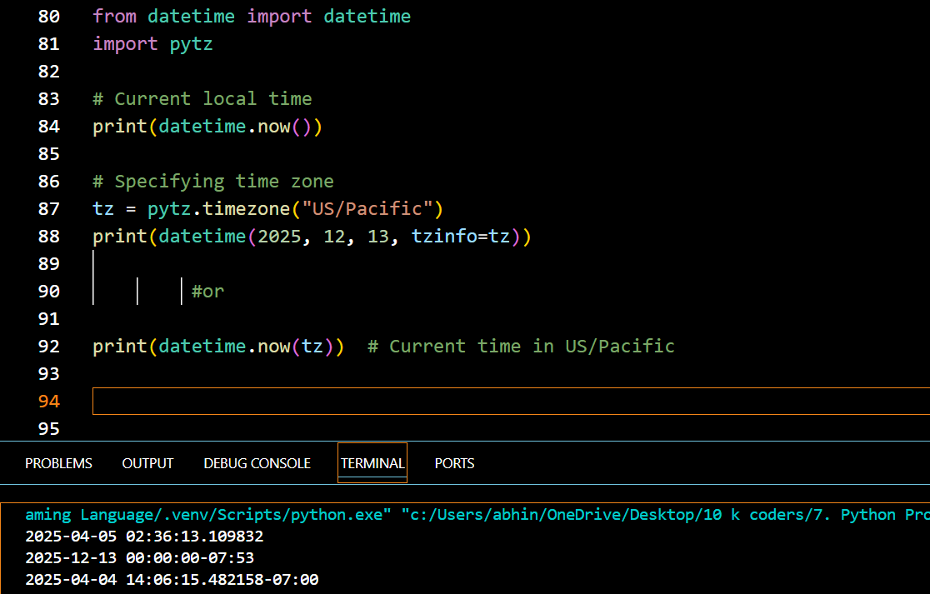

💡 Real-World Example: Countdown Timer

from datetime import datetime, timedelta

event_date = datetime(2025, 12, 31, 23, 59)
now = datetime.now()
remaining = event_date - now

print(f"Time remaining for New Year: {remaining.days} days and {remaining.seconds // 3600} hours")

Would you like a mini-project using datetime like a digital clock, birthday countdown, or age calculator? ⏳

Functions
Python Functions
Python Functions is a block of statements that return the specific task. The idea is to put some commonly or repeatedly done tasks together and make a function so that instead of writing the same code again and again for different inputs, we can do the function calls to reuse code contained in it over and over again.
Some Benefits of Using Functions
Increase Code Readability
Increase Code Reusability
Python Function Declaration
The syntax to declare a function is:
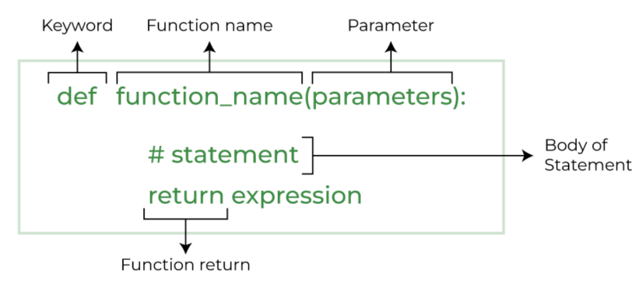
Types of Functions in Python
• Below are the different types of functions in Python:
Built-in library function: These are Standard functions in Python that are available to use.
User-defined function: We can create our own functions based on our requirements.

Creating a Function in Python
We can define a function in Python, using the def keyword. We can add any type of functionalities and properties to it as we require. By the following example, we can understand how to write a function in Python. In this way we can create Python function definition by using def keyword.
Syntax:
# A simple Python function
def fun():
print("Welcome to GFG")

Calling a Function in Python
After creating a function in Python we can call it by using the name of the functions Python followed by parenthesis containing parameters of that particular function. Below is the example for calling def function Python.
Example:
# A simple Python function
def fun():
print("Welcome to GFG")

# Driver code to call a function
fun()

Python Function Arguments
Arguments are the values passed inside the parenthesis of the function. A function can have any number of arguments separated by a comma.
In this example, we will create a simple function in Python to check whether the number passed as an argument to the function is even or odd.
Example:
# A simple Python function to check
# whether x is even or odd
def evenOdd(x):
if (x % 2 == 0):
print("even")
else:
print("odd")

# Driver code to call the function
evenOdd(2)
evenOdd(3)

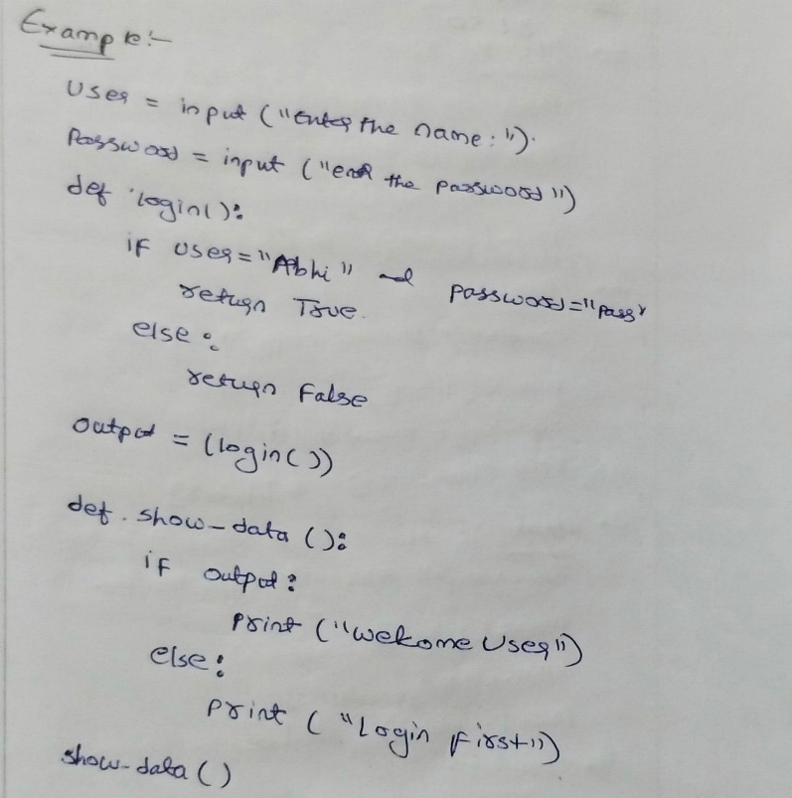
Python Default arguments
A default argument is a parameter that assumes a default value if a value is not provided in the function call for that argument. The following example illustrates Default arguments.
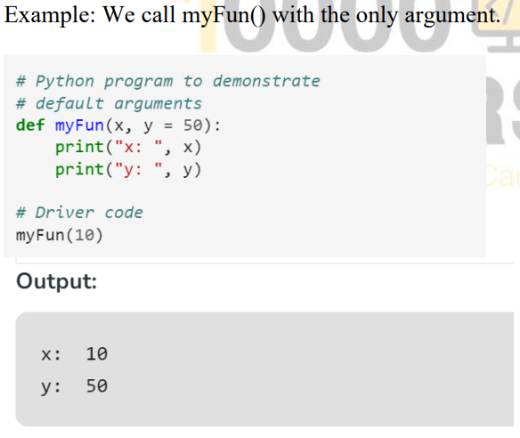

Taking input in Python
input () function first takes the input from the user and converts it into a string. The type of the returned object always will be <class ‘str’>. It does not evaluate the expression it just returns the complete statement as String.

Example-1:
# Python program showing
# a use of input()
val = input("Enter your value: ")
print(val)

Example-2:
username = input("Enter username:")
print("Username is: " + username)

Modules:
A Python module is a file containing Python definitions and statements.
A module can define:
- Functions
- Classes
- Variables
- Runnable code
Grouping related code into a module makes the code easier to understand, use, and maintain. It also keeps code logically organized.

What is Python Module
A Python module is a file containing Python definitions and statements. A module can define functions, classes, and variables. A module can also include runnable code.
Grouping related code into a module makes the code easier to understand and use. It also makes the code logically organized.

Creating a Python Module
Steps
- Create a Python file with .py extension.
- Define your code inside the file.
- Import the module using import or from.

Example
Create a file named:
module1.py

Inside module1.py:
def add(a, b):
return a + b

Create another file, for example:
main.py

Import and use the module:

import module1
print(module1.add(2, 3))

Output
5

Using from to Import
Instead of importing the complete module, we can import a specific function.

from module1 import add
print(add(5, 2))

Output
7
The uploaded notes show both import module1 and from module1 import add

Example Using the math Module
Python provides several built-in modules.
The math module provides mathematical functions.
from math import pow, floor, ceil

print(pow(5, 2))
print(floor(5.23))
print(ceil(5.23))
Output
25.0
5
6

Rules for Creating Modules
According to the uploaded notes:
- Use meaningful names for your modules.
- Avoid conflicts with names of built-in modules.
- Use comments and documentation to explain the purpose of your module.
Packages:
A package is a collection of modules organized in a directory.
Packages help us organize related modules together.

Package Structure
A package can have a structure like this:

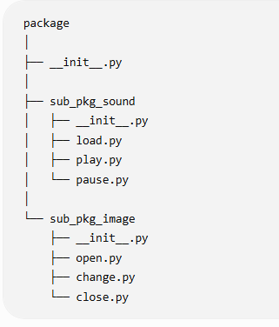

__init__.py
The uploaded notes mention that a package directory should contain:
__init__.py
The __init__.py file can be:
- Empty
- Used to contain initialization code
It helps Python recognize the directory as a package in the structure described in the notes.

Accessing Modules Inside a Package
Modules inside a package can be accessed using dot notation.
For example:
package.module
A package can also contain sub-packages.
Example structure:

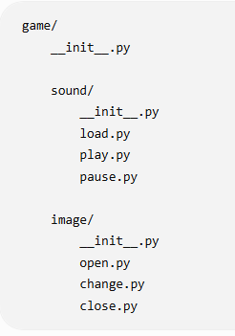
Example of Importing from a Package
The uploaded notes show the following form:
import game.level.start
This demonstrates importing a module through a package hierarchy.

Special Symbols in Functions
The uploaded document also includes two important symbols used when passing arguments to functions:
*args
**kwargs

*args
*args is used to pass a non-keyworded variable-length argument list.
It allows a function to receive multiple positional arguments.
Example 1
def myFun(*args):

for arg in args:
print(arg)

myFun("Hello", "Welcome", "to", "GFG")
Output
Hello
Welcome
to
GFG

*args with a Normal Argument
A normal argument can be combined with *args.
def myFun(arg1, *argv):

print("First argument:", arg1)

for arg in argv:
print(arg)

myFun("Hello", "Welcome", "to", "GFG")
Output
First argument: Hello
Welcome
to
GFG

Example: Add Any Number of Values
def add(*args):

total = 0

for number in args:
total = total + number

return total

print(add(10, 20))
print(add(10, 20, 30))
print(add(1, 2, 3, 4, 5))
Output:
30
60
15
The same function works with different numbers of arguments.

**kwargs
Don't confuse these two:
*args → Multiple positional arguments
**kwargs → Multiple keyword arguments

*args
def fun(*args):
print(args)

fun(10, 20, 30)
Output:
(10, 20, 30)

**kwargs
def fun(**kwargs):
print(kwargs)

fun(name="Abhinav", age=24)
Output:
{'name': 'Abhinav', 'age': 24}

File Handling
File handling means working with files using Python. We can use Python to create, read, write, append, and update files.

Advantages of File Handling in Python: Versatility , Flexibility, User – friendly and Cross-platform

The main function used for file handling is:
open()

Opening a File
Syntax
file = open("filename.txt", "mode")
Example:
file = open("sample.txt", "r")
Here:
- sample.txt → File name
- "r" → Mode

File Modes
Mode | Meaning
"r" | Read
"w" | Write
"a" | Append
"x" | Create

"r" – Read
Opens a file for reading.
file = open("sample.txt", "r")
If the file doesn't exist, an error occurs.

"w" – Write
Opens a file for writing.
file = open("sample.txt", "w")
If the file doesn't exist, Python creates it.
Important: Existing content can be overwritten.

"a" – Append
Adds new content at the end of the file.
file = open("sample.txt", "a")

"x" – Create
Creates a new file.
file = open("sample.txt", "x")

If the file already exists, an error occurs.
These are the four basic file modes covered in your uploaded notes.

Writing to a File
Use write() to write data.
file = open("sample.txt", "w")

file.write("Hello Python")
file.write("\nWelcome to File Handling")

file.close()
This creates sample.txt and writes the text into it.

Reading a File
Use read() to read the complete file.

file = open("sample.txt", "r")
data = file.read()
print(data)
file.close()

readline()

readline() reads one line from a file.
file = open("sample.txt", "r")
print(file.readline())
file.close()

readlines()

readlines() reads all lines and returns them as a list.
file = open("sample.txt", "r")
lines = file.readlines()
print(lines)
file.close()

Your uploaded notes specifically include read(), readline(), and readlines() for reading files.

Appending to a File
Use "a" mode when you want to add content without removing existing content.

file = open("sample.txt", "a")
file.write("\nThis is a new line")
file.close()

with open()
A better way to work with files is using with.

with open("sample.txt", "r") as file:
data = file.read()
print(data)

The file is automatically closed after the with block.

Writing Multiple Lines

with open("sample.txt", "w") as file:
file.write("Python\n")
file.write("Java\n")
file.write("C++\n")

writelines()
writelines() can write multiple strings to a file.

lines = [
"Python\n",
"Java\n",
"C++\n"
]
with open("sample.txt", "w") as file:
file.writelines(lines)

Updating a File
To update a particular line, one simple approach is:

with open("sample.txt", "r") as file:
lines = file.readlines()

lines[1] = "JavaScript\n"

with open("sample.txt", "w") as file:
file.writelines(lines)

Here:
- File is opened in read mode.
- Lines are stored in a list.
- Required line is changed.
- File is opened in write mode.
- Updated lines are written back.
This update approach is also shown in your uploaded notes.

Closing a File
When using open() directly, use:

file.close()

Example:
file = open("sample.txt", "r")
data = file.read()
print(data)
file.close()
When using with open(), Python handles closing automatically.

Deleting a File
Python's os module can be used to delete a file.
import os
os.remove("sample.txt")

It's safer to check whether the file exists first:
import os
if os.path.exists("sample.txt"):
os.remove("sample.txt")
print("File deleted")
else:
print("File does not exist")
This deletion approach is included in your uploaded file-handling notes.

Error Handling
Error handling is used to handle errors that occur while a Python program is running.
Instead of allowing the program to stop suddenly, we can use error-handling statements to handle the error properly.

The main keywords are:
try
except
else
finally
raise

Why Do We Need Error Handling?
Consider this program:
a = int(input("Enter a number: "))
b = int(input("Enter another number: "))

print(a / b)
If the user enters:
10
0

Python produces:
ZeroDivisionError
The program stops.
With error handling, we can handle the problem.

Errors and Their Types in Python
Errors in Python occur when the interpreter encounters something it cannot execute. Errors can be broadly classified into syntax errors and exceptions.

1. Syntax Errors (Compile-Time Errors)
A SyntaxError occurs when the Python interpreter finds an incorrect syntax (wrong grammar of Python).
Example:
if True
print("Hello")
Error Output:
SyntaxError: expected ':'
✔ Fix: Add a colon : after if True.

2. Exceptions (Runtime Errors)
Exceptions occur at runtime when a valid syntax is executed but results in an error.
Types of Exceptions in Python
Here are some common types of exceptions:
(i) NameError
Occurs when trying to use a variable that is not defined.
print(x) # x is not defined
Error Output:
NameError: name 'x' is not defined
✔ Fix: Define x before using it.

(ii) TypeError
Occurs when an operation is performed on an incompatible type.
print(5 + "hello") # Integer + String
Error Output:
TypeError: unsupported operand type(s) for +: 'int' and 'str'
✔ Fix: Convert data types before operations:
print(str(5) + "hello") # Output: 5hello

(iii) ValueError
Occurs when a function receives an argument of the correct type but an inappropriate value.
num = int("abc") # Cannot convert "abc" to an integer
Error Output:
ValueError: invalid literal for int() with base 10: 'abc'
✔ Fix: Ensure valid input before conversion.

(iv) IndexError
Occurs when trying to access an index that is out of range.
lst = [1, 2, 3]
print(lst[5]) # Index out of
range
Error Output:
IndexError: list index out of range
✔ Fix: Check list length before accessing indexes.

(v) KeyError
Occurs when trying to access a dictionary key that does not exist.
my_dict = {"a": 1, "b": 2}
print(my_dict["c"]) # Key 'c' does not exist
Error Output:
KeyError: 'c'
✔ Fix: Use .get() to handle missing keys:
print(my_dict.get("c", "Key not found")) # Output: Key not found

(vi) AttributeError
Occurs when trying to access an attribute that does not exist.
x = 10
x.append(5) # Integers do not have an append() method
Error Output:
AttributeError: 'int' object has no attribute 'append'
✔ Fix: Use correct data types.

(vii) ZeroDivisionError
Occurs when trying to divide a number by zero.
print(10 / 0)
Error Output:
ZeroDivisionError: division by zero
✔ Fix: Ensure the denominator is not zero before dividing.

(viii) FileNotFoundError
Occurs when trying to open a file that does not exist.
with open("nonexistent_file.txt", "r") as f:
content = f.read()
Error Output:
FileNotFoundError: [Errno 2] No such file or directory: 'nonexistent_file.txt'
✔ Fix: Check if the file exists before opening.

(ix) ImportError / ModuleNotFoundError
Occurs when trying to import a module that does not exist.
import non_existent_module
Error Output:
ModuleNotFoundError: No module named 'non_existent_module'
✔ Fix: Install or check the module name.

try and except
The basic syntax is:
try:
# Code that may produce an error
except:
# Code to handle the error
Example
try:
a = int(input("Enter a number: "))
b = int(input("Enter another number: "))

print(a / b)

except:
print("Something went wrong")
If the user enters 10 and 0:
Something went wrong

Handling a Specific Error
It is better to specify the type of error.
ZeroDivisionError
try:
a = 10
b = 0

print(a / b)

except ZeroDivisionError:
print("Cannot divide by zero")
Output:
Cannot divide by zero

ValueError
ValueError occurs when a function receives an inappropriate value.
Example:
try:
number = int(input("Enter a number: "))
print(number)

except ValueError:
print("Please enter a valid number")
If the user enters:
abc
Output:
Please enter a valid number

NameError
A NameError occurs when we try to use a variable that has not been defined.
try:
print(name)
except NameError:
print("Variable is not defined")
Output:
Variable is not defined

TypeError
A TypeError occurs when an operation is performed on incompatible data types.
try:
a = 10
b = "20"

print(a + b)

except TypeError:
print("Cannot add integer and string")
Output:
Cannot add integer and string

IndexError
An IndexError occurs when we try to access an index that doesn't exist.
try:
numbers = [10, 20, 30]

print(numbers[5])

except IndexError:
print("Index does not exist")
Output:
Index does not exist

KeyError
A KeyError occurs when we try to access a dictionary key that doesn't exist.
try:
student = {
"name": "Abhinav",
"age": 24
}

print(student["city"])

except KeyError:
print("Key does not exist")
Output:
Key does not exist

Multiple except Blocks
We can handle different errors separately.
try:
a = int(input("Enter first number: "))
b = int(input("Enter second number: "))

print(a / b)

except ValueError:
print("Please enter numbers only")

except ZeroDivisionError:
print("Cannot divide by zero")

else
The else block executes when no error occurs.
Syntax
try:
# Code

except:
# Error

else:
# No error
Example
try:
a = 10
b = 2

result = a / b

except ZeroDivisionError:
print("Cannot divide by zero")

else:
print("Result:", result)
Output:
Result: 5.0

finally
The finally block always executes, whether an error occurs or not.
Example
try:
a = 10
b = 0

print(a / b)

except ZeroDivisionError:
print("Cannot divide by zero")

finally:
print("Program completed")
Output:
Cannot divide by zero
Program completed

try + except + else + finally
All four can be used together.
try:
number = int(input("Enter a number: "))

except ValueError:
print("Invalid input")

else:
print("You entered:", number)

finally:
print("Thank you")

Using as
We can store the error message in a variable using as.
try:
number = int("abc")

except ValueError as error:
print("Error:", error)
The error variable contains information about the exception.

raise
The raise statement is used to manually generate an exception.
Example
age = 15

if age < 18:
raise ValueError("Age must be 18 or above")
Output:
ValueError: Age must be 18 or above

raise with try-except
try:

age = int(input("Enter your age: "))

if age < 18:
raise ValueError("You must be 18 or above")

print("Eligible")

except ValueError as error:
print("Error:", error)

OOPs
OOPs stands for Object-Oriented Programming System (commonly called Object-Oriented Programming).

Object-Oriented Programming (OOP) is a programming paradigm that organizes software design around objects, which represent real-world entities. These objects encapsulate data (attributes) and behavior (methods), making the code more modular and reusable.

It is a way of writing Python programs using classes and objects.
OOP is a programming approach where we organize data and functions together inside classes and create objects from those classes.

Think about a Student:
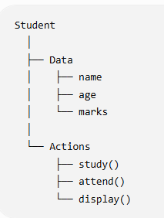

Example:
class Student:
def __init__(self, name, age):
self.name = name
self.age = age

def display(self):
print(self.name, self.age)

s1 = Student("Abhinav", 22)
s1.display()

Here:
- Student → Class
- s1 → Object
- name, age → Data/Attributes
- display() → Method

Why do we use OOP?
- Organize large programs
- Reuse code
- Protect data
- Maintain code easily
- Build complex applications more easily

Key Concepts of OOP in Python
- Class – A blueprint for creating objects.
- Object – An instance of a class.
- Encapsulation – Hiding the internal details of an object and restricting direct access to some of its components.
- Abstraction – Hiding complex implementation details and exposing only the necessary parts.
- Inheritance – A mechanism that allows a new class to derive properties and behavior from an existing class.
- Polymorphism – The ability to take multiple forms, e.g., methods with the same name but different implementations in different classes.

OOP follows four main principles:
- Encapsulation – Hiding the internal state of an object and restricting access to it.
- Abstraction – Hiding complex implementation details and exposing only the necessary parts.
- Inheritance – Enabling new classes to derive properties and methods from existing ones.
- Polymorphism – Allowing the same interface to be used for different underlying data types.

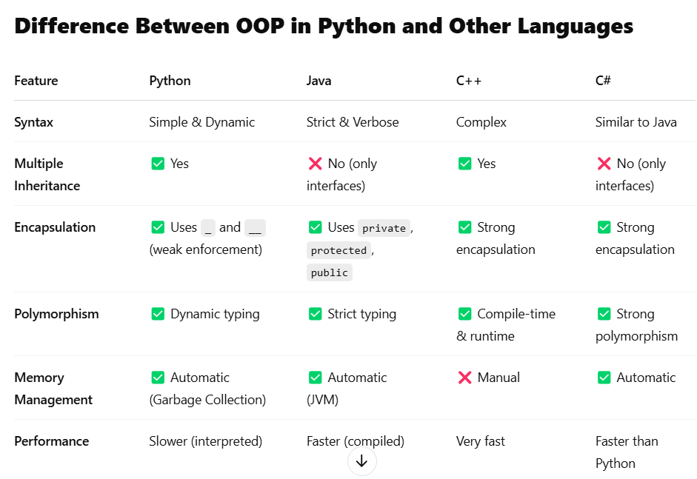
Benefits of OOP
✅ 1. Code Reusability (DRY Principle)
- Inheritance allows reusing existing code without rewriting it.
- Example: A Car class can be reused in multiple projects.
✅ 2. Modularity (Easier Code Organization)
- Classes help break down large code into smaller, manageable parts.
- Example: A BankAccount class can have different methods like deposit() and withdraw().
✅ 3. Encapsulation (Data Security)
- Prevents direct modification of sensitive data.
- Example: A private __balance attribute in a BankAccount class.
✅ 4. Scalability & Flexibility
- Polymorphism allows the same method to work for different types.
- Example: A make_sound() method can work for both Dog and Cat classes.
✅ 5. Real-World Representation
- Objects model real-world entities, making software design intuitive.
- Example: Car, Employee, Customer, etc.

Class
A class is a blueprint or template used to create objects in Python.

A class in Python is a blueprint or template for creating objects. It defines attributes (variables) and methods (functions) that the objects will have.

Syntax of a Class in Python
class ClassName:
# Constructor (optional)
def __init__(self, param1, param2):
self.param1 = param1
self.param2 = param2

# Method
def method_name(self):
print("Method executed")

- class keyword is used to define a class.
- __init__() is a special method (constructor) that initializes object attributes.
- self represents the instance of the class.

Think about a house blueprint 🏠:
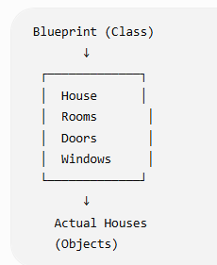
The blueprint is not the actual house. It describes how the house should be built.
Similarly:
Class = Blueprint
Object = Actual thing created from the blueprint

Example
class Student:
name = "Abhinav"
age = 22
Here, Student is a class.
We can create an object:
s1 = Student()

print(s1.name)
print(s1.age)

Output:
Abhinav
22

Class with a method
A class can contain both data and functions:

class Student:
name = "Abhinav"

def study(self):
print("Student is studying")

s1 = Student()
print(s1.name)
s1.study()

Output:
Abhinav
Student is studying

Here study() is called a method because it is a function inside a class

Object
An object is a simply a collection of data(variable) and Methods(functions) that act on those data. Similarly, a class is a blueprint of an object.

An object (instance) is an instantiation of a class. When class is defined, only the description for the object is defined. Therefore, no memory or storage is allocated.

There is no memory allocation until we create its object. The Objector Instance Contains real Data or Information

Example:
class Abhi():
def Output(self):
print("Hello World")

vivo=Abhi()
vivo.Output()

Multiple objects
One class can create many objects:
class Student:
pass

s1 = Student()
s2 = Student()
s3 = Student()

Real-world example
Class → Car
Objects → BMW, Audi, Toyota
The Car class describes what a car can have/do, while individual cars are objects.

Example-2:
class Kiran(): # class keyword class name
a=10 # data member
def Output(self): # method(self)
print(self.a)
obj=Kiran() # declaring of object
obj.Output() # using object we can call the methods

self Keyword:
We can acess the attribute and methods of the class (current class only)
Example:
class Abhi():
def Output(self):
print("Hello World")

vivo=Abhi()
vivo.Output()
Example-2:
class Abhi():
a=10
def show(self):
print("this is class")
# obj name=class name()
sai=Abhi()
print(sai.a)
sai.show()

Example-3:
class Abhi():
a=10 #attribute
def display(self):
print(self.a)

A1=Abhi()
A2=Abhi()
A1.display()
A2.display()

constructor
- Constructor is a special method that is Automatically called when you create an object.
- Constructors are generally used for instantiating an object.
- The task of constructors is to initialize(assign values)
- Constructor = Object's initial setup
- In Python the __init__() method is called the constructor and is always called when an object is created
- does'nt support multiple constructor

Example-1:
For example,
when you create a student, you may want to give the student a name and age immediately.

class Student:
def __init__(self, name, age):
self.name = name
self.age = age

s1 = Student("Abhinav", 22)
print(s1.name)
print(s1.age)

Output:
Abhinav
22

Why do we use a constructor?
We use it to initialize an object's data when the object is created.
For example:
class Employee:

def __init__(self, name, salary):
self.name = name
self.salary = salary

e1 = Employee("Abhinav", 30000)
e2 = Employee("Rahul", 40000)

Now:
e1 → name = Abhinav, salary = 30000
e2 → name = Rahul, salary = 40000

Important terms
def __init__(self, name, age):
- __init__ → constructor/initializer method
- self → current object
- name, age → parameters
- self.name, self.age → object attributes

Example-2:
class Abhi():
def __init__(self,a,b,c):
self.A1=a
self.B1=b
self.C1=c

def Output(self):
print(self.A1, self.B1, self.C1)
p=Abhi(1,2,3)
p.Output()

Example-3:
class Mobiles():
def __init__(self,Mobile_name,Mobile_Ram,Mobile_battery,Mobile_Price):
self.a=Mobile_name
self.c=Mobile_Ram
self.d=Mobile_battery
self.e=Mobile_Price

def Mobile_Data(self):
print("Mobile Name:",self.a)
print("Mobile Ram:",self.c)
print("Mobile Battery:",self.d)
print("Mobile Price:",self.e)

name=input("Enter the Mobile Name:")
ram=input("Enter the Mobile Ram:")
bat=input("Enter the Mobile Battery:")
Price=float(input("Enter the Mobile Price:"))

Mobile_obj=Mobiles(name,ram,bat,Price)
Mobile_obj.Mobile_Data()

Example-4:
class Bikes():
def __init__(self, bike_name, bike_cc, millage):
self.a=bike_name
self.b=bike_cc
self.c=millage

def Bike_Data(self):
print("Bike Name:", self.a)
print("Bike CC:", self.b)
print("Bike Millage:", self.c)

bike_name = input("Enter Bike-1 Name")
bike_cc = input("Enter Bike-1 CC")
millage = input("Enter Bike-1 Millage")
Bike1 = Bikes(bike_name, bike_cc, millage)
Bike1.Bike_Data()

bike_name = input("Enter Bike-2 Name")
bike_cc = input("Enter Bike-2 CC")
millage = input("Enter Bike-2 Millage")

Bike2 = Bikes(bike_name, bike_cc, millage)
Bike2.Bike_Data()

Inheritance
Inheritance is a fundamental concept of Object-Oriented Programming (OOP) that allows one class (child/subclass) to inherit the attributes and methods of another class (parent/base class).
It enables code reusability, hierarchical class organization, and extensibility in programs.

Inheritance is an OOP concept where a child class gets the properties and methods of a parent class.

Types of Inheritance in Python
Python supports five types of inheritance:
- Single Inheritance – One child class inherits from one parent class.
- Multiple Inheritance – A child class inherits from multiple parent classes.
- Multilevel Inheritance – A child class inherits from another child class (grandparent → parent → child).
- Hierarchical Inheritance – Multiple child classes inherit from a single parent class.
- Hybrid Inheritance – A combination of two or more types of inheritance.

Example:
class Parent:
def eat(self):
print("Eating")

class Child(Parent):
def play(self):
print("Playing")

Now create an object of Child:
c = Child()

c.eat()
c.play()

Output:
Eating
Playing

Notice something important:
eat() was defined inside Parent, but the Child object can use it.
That's inheritance.

Why do we use inheritance
1. Code Reusability
2. Avoid duplicate code

Types of Inheritance
Python supports several forms.
1. Single Inheritance
One parent → One child
Example:
class Parent:
def output(self):
print('this is parent class')
class Child(Parent):
def outputChild(self): # output
print('this is child class')
i=Child()
i.output()
i.outputChild()

2. Multilevel Inheritance
Grandparent → Parent → Child
Example:

class Father:
def output(self):
print('this is parent class')
class Mother:
def outputM(self):
print('this is mother class')
class Child(Father,Mother):
def outputChild(self):
print('this is child class')
ice=Child()
ice.output()
ice.outputM()
ice.outputChild()

3. Multiple Inheritance
One child → Multiple parents
Example:

class Father:
def output(self):
print('this is parent class')
class Mother:
def outputM(self):
print('this is mother class')
class Child(Father,Mother):
def outputChild(self):
print('this is child class')
ice=Child()
ice.output()
ice.outputM()
ice.outputChild()

4. Hierarchical Inheritance
One parent → Multiple children
Example:

class Father:#100cr
def output(self):
print('this is father class')

class Child1(Father):#50cr
def outputf(self):
print('this is child 1 class')

class Child2(Father):#50cr
def outputChild(self):
print('this is child 2 class')
ice=Child1()
cream=Child2()
ice.output() #child 1 of parent
ice.outputf()
cream.output() # child 2 of parent
cream.outputChild() # child 2

Polymorphism
Polymorphism is an OOP concept where the same method or operation can behave differently depending on the object.

Easy meaning of the word
Poly = Many
Morph = Forms

So:
Polymorphism = One thing having many forms.

Example
Both Dog and Cat have a method called sound(), but they behave differently.

class Dog:
def sound(self):
print("Bark")

class Cat:
def sound(self):
print("Meow")

dog = Dog()
cat = Cat()

dog.sound()
cat.sound()

Output
Bark
Meow
Here, the method name is the same:
sound()
But the behavior is different:
Dog → Bark
Cat → Meow
This is polymorphism.

Why do we use polymorphism?
Polymorphism helps us write:

1. Flexible code
def make_sound(animal):
animal.sound()
This function can work with different objects:
make_sound(Dog())
make_sound(Cat())

2. Reusable code
Instead of creating separate functions for every object, one common operation can work with multiple object types.

Method Overloading
Method overloading means having multiple methods with the same name but different parameters.
For example, in some programming languages:
add(a, b)
add(a, b, c)
Both methods are named add, but they accept different numbers of parameters.

Example:
class Methodoverlod:
def something(self,a=None,b=None,c=None):
print(a,b,c)
obj=Methodoverlod()
obj.something(1,2,3)
obj.something(1,2)
obj.something(1)
obj.something()

Important: Python does not support traditional method overloading
If you define the same method name multiple times in a Python class, the last definition replaces the previous one.
class Calculator:

def add(self, a, b):
print(a + b)

def add(self, a, b, c):
print(a + b + c)
Now:
c = Calculator()

c.add(10, 20, 30)
Python uses only the last add() method.
The first one is overwritten.

How do we achieve overloading-like behavior in Python?
1. Using Default Arguments
class Calculator:

def add(self, a, b, c=0):
print(a + b + c)
Now:
c = Calculator()

c.add(10, 20)
c.add(10, 20, 30)
Output:
30
60

2. Using *args
class Calculator:

def add(self, *numbers):
print(sum(numbers))
Now:
c = Calculator()

c.add(10, 20)
c.add(10, 20, 30)
c.add(10, 20, 30, 40)
Output:
30
60
100

Method Overloading vs Method Overriding
Method Overloading | Method Overriding
Same class | Parent and child classes
Same method name | Same method name
Different parameters | Same method signature is commonly used
Python doesn't support traditional form | Python supports it
Achieved using *args or defaults | Child changes parent method behavior

Method Overriding
Method overriding happens when a child class provides its own implementation of a method that already exists in the parent class.

Parent has a method → Child changes that method

Example
class Animal:

def sound(self):
print("Animal makes a sound")

class Dog(Animal):
def sound(self):
print("Dog barks")

Now:
dog = Dog()
dog.sound()

Output
Dog barks

What happened here?

The parent class:
class Animal:
def sound(self):
print("Animal makes a sound")

has a method called:
sound()

The child class Dog also creates a method with the same name:
class Dog(Animal):
def sound(self):
print("Dog barks")

So the child's method overrides the parent's method.

super()
super() is used to access the parent class from a child class.

Example 1: Calling Parent Method
class Parent:
def show(self):
print("Parent method")

class Child(Parent):
def show(self):
super().show() # Calls parent method
print("Child method")

c = Child()
c.show()

Output
Parent method
Child method

Example 2: Using super() with Constructor
This is a very common use of super().
class Parent:
def __init__(self, name):
self.name = name

class Child(Parent):
def __init__(self, name, age):
super().__init__(name)
self.age = age

c = Child("Abhinav", 22)

print(c.name)
print(c.age)

Output
Abhinav
22

Example:
class Methodoverri:
def display(self):
print("this is parent class")

class Child(Methodoverri):
def display(self):
print("this is child class")
super().display()

obj=Child()
obj.display()

Encapsulation
Encapsulation is an OOP concept where we combine data (variables) and methods (functions) inside a class and control access to the data.

Encapsulation = Data + Methods together + Control data access

Real-life example 🏦
Think about a bank account.
Your balance should not be freely changed from anywhere in the program.
Instead:
Bank Account
│
├── Balance 🔒
│
├── deposit()
├── withdraw()
└── get_balance()
You use methods to interact with the balance.

Example in Python
class BankAccount:

def __init__(self, balance):
self.__balance = balance

def deposit(self, amount):
self.__balance += amount

def get_balance(self):
return self.__balance

account = BankAccount(1000)
account.deposit(500)

print(account.get_balance())

Output
1500

What does __balance mean?
self.__balance
The double underscore (__) indicates a private attribute convention with name mangling in Python.
It is used to prevent normal direct access such as:
account.__balance
Instead, access or modify the value through methods:
account.deposit(500)

print(account.get_balance())

Access levels in Python
Python commonly uses these naming conventions:
public_var # Public
_protected_var # Protected convention
__private_var # Private-like via name mangling
⚠️ Important: Python does not enforce access modifiers exactly like languages such as Java. These are mainly conventions, and __name uses name mangling, not absolute privacy.

Example-1:
class GFather:
def __init__(self,a):
self._y=a
print(self._y)
class Father(GFather):
def display1(self):
print(self._y)
class Child2(Father):
def display2(self):
print("child2",self._y)
obj=Child2(12)
obj.display2()
obj.display1()

Output:
12
child2 12
12

Example-2:
class GFather:
def __init__(self,a):
self.__y=a
print(self.__y)
class Father(GFather):
def display1(self):
print(self.__y)
class Child2(Father):
def display2(self):
print("child2",self.__y)
obj=Child2(12)
obj.display2()
obj.display1()

Output:
12
Traceback (most recent call last):
File "e:\Python Life\1. Python Full Stack\Day-11 Opps and ML intro\task-31 oops practice.py", line 180, in <module>
obj.display2()
File "e:\Python Life\1. Python Full Stack\Day-11 Opps and ML intro\task-31 oops practice.py", line 178, in display2
print("child2",self.__y)
^^^^^^^^
AttributeError: 'Child2' object has no attribute '_Child2__y'

Abstraction
Abstraction means hiding unnecessary implementation details and showing only the important features to the user.

Abstraction = Hide complexity and show only what is necessary.

Real-life Example: Car 🚗
When you drive a car:
You press Start
↓
Car starts
You know how to use the car, but you don't need to know all the internal engine operations.

What you see What is hidden
──────────── ──────────────
Start button Engine process
Steering wheel Internal mechanism
Accelerator Fuel system

This is abstraction.

Abstraction in Python
Python provides abstraction using the abc module.
abc means:
Abstract Base Class
Example:
from abc import ABC, abstractmethod

class Animal(ABC):

@abstractmethod
def sound(self):
pass
Here:
- Animal is an abstract class
- sound() is an abstract method

What is an Abstract Method?
An abstract method is a method that has a declaration but does not provide the complete implementation in the abstract class.
@abstractmethod
def sound(self):
pass
It tells child classes:
"You must create your own sound() method."

Child Classes
from abc import ABC, abstractmethod

class Animal(ABC):

@abstractmethod
def sound(self):
pass

class Dog(Animal):

def sound(self):
print("Bark")

class Cat(Animal):

def sound(self):
print("Meow")
Now:
dog = Dog()
cat = Cat()

dog.sound()
cat.sound()
Output
Bark
Meow

Example:
from abc import ABC, abstractmethod
class Car(ABC):
@abstractmethod
def mileage(self):
pass
class Tesla(Car):
def mileage(self):
print("The mileage is 30kmph")
class Suzuki(Car):
def mileage(self):
print("The mileage is 25kmph ")
class Duster(Car):
def mileage(self):
print("The mileage is 24kmph ")
class Renault(Car):
def mileage(self):
print("The mileage is 27kmph ")
# Driver code

t= Tesla ()
t.mileage()
r = Renault()
r.mileage()
s = Suzuki()
s.mileage()
d = Duster()
d.mileage()

Introduction to Machine Learning:

NumPy

What is NumPy?
NumPy stands for Numerical Python. It is a Python library for numerical computing and is mainly used for working with arrays, matrices, large datasets, and mathematical operations efficiently. Its core array object is called ndarray (N-dimensional array).

NumPy supports multi-dimensional arrays and provides mathematical functions that can operate on whole arrays. The supplied notes also describe NumPy as a foundation used with tools such as Pandas, Scikit-learn and TensorFlow.

Example
import numpy as np
arr = np.array([10, 20, 30, 40])
print(arr)

Output:
[10 20 30 40]

Installing and Importing NumPy
NumPy can be installed using pip and commonly imported with the alias np.

Example
# Install from Command Prompt / Terminal
pip install numpy
# Import in Python
import numpy as np

NumPy Array (ndarray)
The main data structure in NumPy is ndarray, which means N-dimensional array. It can represent 1-D, 2-D, 3-D, and higher-dimensional data.

Example
import numpy as np
a = np.array([1, 2, 3]) # 1-D
b = np.array([[1, 2], [3, 4]]) # 2-D
c = np.array([[[1, 2], [3, 4]],
[[5, 6], [7, 8]]]) # 3-D
print(a)
print(b)
print(c)

Python List vs NumPy Array
A Python list is a flexible built-in collection that can contain different data types. A NumPy array is designed for numerical data and normally stores elements using a common data type.
Feature | Python List | NumPy Array
Data type | Can contain mixed types | Normally homogeneous
Numerical operations | Usually require loops | Vectorized operations
Memory | More overhead | Efficient for numerical data
Dimensions | Nested lists | Native N-dimensional arrays
Typical use | General-purpose collections | Numerical/data processing

Example
numbers = [1, 2, 3]
arr = np.array([1, 2, 3])
# NumPy performs the operation element by element
print(arr + 5)

Output:
[6 7 8]

Dimensions of NumPy Arrays
The dimension tells how many levels of array structure are present. A 1-D array is like a single row, a 2-D array is like a table, and a 3-D array can be thought of as a stack of tables.

Example
a = np.array(10) # 0-D
b = np.array([1, 2, 3]) # 1-D
c = np.array([[1, 2, 3], [4, 5, 6]]) # 2-D
d = np.array([[[1, 2], [3, 4]],
[[5, 6], [7, 8]]]) # 3-D
print(a.ndim, b.ndim, c.ndim, d.ndim)

Output:
0 1 2 3

Creating NumPy Arrays
NumPy provides several functions for creating arrays with specific values, shapes, sequences, or patterns.

np.array()
Definition: np.array() is used to create an array using the pattern shown in the example.

Example
a = np.array([1, 2, 3])
print(a)

Output:
[1 2 3]

np.arange()
Definition: np.arange() is used to create an array using the pattern shown in the example.

Example
a = np.arange(1, 11, 2)
print(a)
Output:
[1 3 5 7 9]

np.zeros()
Definition: np.zeros() is used to create an array using the pattern shown in the example.

Example
a = np.zeros((2, 3), dtype=int)
print(a)
Output:
[[0 0 0]
[0 0 0]]

np.ones()
Definition: np.ones() is used to create an array using the pattern shown in the example.

Example
a = np.ones((2, 3), dtype=int)
print(a)
Output:
[[1 1 1]
[1 1 1]]

np.full()
Definition: np.full() is used to create an array using the pattern shown in the example.

Example
a = np.full((2, 3), 111)
print(a)
Output:
[[111 111 111]
[111 111 111]]

np.eye()
Definition: np.eye() is used to create an array using the pattern shown in the example.

Example
a = np.eye(3)
print(a)
Output:
[[1. 0. 0.]
[0. 1. 0.]
[0. 0. 1.]]

np.diag()
Definition: np.diag() is used to create an array using the pattern shown in the example.

Example
a = np.diag([1, 2, 3])
print(a)
Output:
[[1 0 0]
[0 2 0]
[0 0 3]]

np.linspace()
Definition: np.linspace() is used to create an array using the pattern shown in the example.

Example
a = np.linspace(0, 1, 5)
print(a)
Output:
[0. 0.25 0.5 0.75 1. ]

Array Attributes
Array attributes provide information about an array, such as its dimensions, shape, number of elements, data type, and memory size per element.

Example
a = np.array([[1, 2, 3], [4, 5, 6]])
print("ndim:", a.ndim)
print("shape:", a.shape)
print("size:", a.size)
print("dtype:", a.dtype)
print("itemsize:", a.itemsize)

Common attributes:
- ndim — number of dimensions.
- shape — size of the array along each dimension.
- size — total number of elements.
- dtype — data type of the elements.
- itemsize — number of bytes used by one array element.

Data Types and dtype
NumPy provides data types for integers, booleans, unsigned integers, floating-point values, complex values, strings, Unicode strings, dates/times, objects, and other representations.
Common type codes from the supplied documentation include: i (integer), b (boolean), u (unsigned integer), f (float), c (complex float), m (timedelta), M (datetime), O (object), S (string), U (Unicode string), and V (void/fixed memory chunk).

Example
arr = np.array([1, 2, 3, 4], dtype="int32")
print(arr)
print(arr.dtype)
Output:
[1 2 3 4]
int32

Indexing Arrays
Indexing means accessing a particular element of an array. NumPy uses zero-based indexing, so the first element has index 0.

Example
arr = np.array([10, 20, 30, 40])
print(arr[0])
print(arr[2])
Output:
10
30

Indexing a 2-D Array

Example
arr = np.array([[1, 2, 3],
[4, 5, 6]])
print(arr[0, 1]) # first row, second column
print(arr[1, 2]) # second row, third column)
Output:
2
6

Slicing Arrays
Slicing extracts a range of elements. The basic syntax is [start:end], and the extended form is [start:end:step]. The end index is not included.

Example
arr = np.arange(1, 11)
print(arr[0:5]) # first five elements
print(arr[5:]) # index 5 to the end
print(arr[1:8:2]) # every second element
print(arr[::-1]) # reverse order
Output:
[1 2 3 4 5]
[ 6 7 8 9 10]
[2 4 6 8]
[10 9 8 7 6 5 4 3 2 1]

2-D Slicing

Example
a = np.array([[1, 2, 3],
[4, 5, 6],
[7, 8, 9]])
print(a[:, 1]) # all rows, second column
print(a[1, :]) # second row
print(a[0:2, 1:3]) # selected rows and columns)

Reshaping Arrays
Reshaping changes the arrangement of an array without changing the underlying data values. The new shape must contain the same total number of elements.

Example
x = np.arange(1, 13)
new_x = x.reshape(3, 4)
print(new_x)
print(new_x.shape)
Output:
[[ 1 2 3 4]
[ 5 6 7 8]
[ 9 10 11 12]]
(3, 4)

Flatten, Ravel and Reshape
reshape() changes the dimensions, flatten() converts an array to one dimension as a separate flattened result, and ravel() returns a flattened array representation. The supplied notebook demonstrates ravel() and flatten() for converting multi-dimensional arrays to one dimension.

Example
a = np.array([[1, 2, 3], [4, 5, 6]])
print(a.reshape(3, 2))
print(a.flatten())
print(a.ravel())
Output:
[[1 2]
[3 4]
[5 6]]
[1 2 3 4 5 6]
[1 2 3 4 5 6]

Copy vs View
A view shares the same underlying data with the original array, while a copy creates an independent array. Therefore, changes made through a view can affect the original, whereas changes to a copy do not.

Example
x1 = np.arange(5)
x2 = x1.view()
x2[0] = 100
print(x1)
print(x2)
print(np.shares_memory(x1, x2))
Output:
[100 1 2 3 4]
[100 1 2 3 4]
True

Example
x1 = np.arange(5)
x2 = x1.copy()
x2[0] = 100
print(x1)
print(x2)
print(np.shares_memory(x1, x2))
Output:
[0 1 2 3 4]
[100 1 2 3 4]
False

Conditions and Filtering
NumPy supports boolean conditions and boolean indexing. A condition produces True/False values, and those boolean values can be used to select matching elements.

Example
a = np.array([1, 2, 3, 4, 5, 6])
print(a > 3)
print(a[a > 3])
print(a[(a > 2) & (a < 6)])
Output:
[False False False True True True]
[4 5 6]
[3 4 5]

Filtering with a Boolean Index List
Definition: Filtering creates a new array containing only the elements whose corresponding boolean value is True.

Example
arr = np.array([41, 42, 43, 44])
filter_index = [True, False, True, False]
new_arr = arr[filter_index]
print(new_arr)
Output:
[41 43]

Transpose
Transpose changes the orientation of a 2-D array so that rows become columns and columns become rows.

Example
a = np.array([[1, 2, 3],
[4, 5, 6]])
print(a.transpose())
Output:
[[1 4]
[2 5]
[3 6]]

Stacking Arrays
Stacking combines arrays. The supplied notebook introduces hstack() and vstack() as helpers for stacking arrays in different directions.

Example
a = np.array([1, 2, 3])
b = np.array([4, 5, 6])
print(np.vstack((a, b)))
print(np.hstack((a, b)))
Output:
[[1 2 3]
[4 5 6]]
[1 2 3 4 5 6]

18. Insert and Delete
Definition: np.insert() inserts values before a specified index, while np.delete() removes values at the specified index.

Example
arr = np.array([10, 20, 30, 40])
print(np.insert(arr, 2, 99))
print(np.delete(arr, 1))
Output:
[10 20 99 30 40]
[10 30 40]

Arithmetic and Mathematical Operations
NumPy supports element-wise arithmetic and many mathematical functions. Vectorized operations allow calculations to be applied directly to arrays.

Example
a = np.array([1, 2, 3])
print(a + 2)
print(a - 1)
print(a * 3)
print(a / 2)
Output:
[3 4 5]
[0 1 2]
[3 6 9]
[0.5 1. 1.5]

Mathematical Functions

Example
a = np.array([1, 4, 9])
print(np.sqrt(a))
print(np.power(a, 2))
print(np.exp(a))

Trigonometric Functions

Example
a = np.array([0, 1, 2])
print(np.sin(a))
print(np.cos(a))
print(np.tan(a))

Aggregate Functions and Axis
Aggregate functions reduce multiple values into summary results such as sum, mean, maximum, minimum, median, and standard deviation.

Example
a = np.array([[1, 2, 3],
[4, 5, 6],
[7, 8, 9]])
print("sum:", np.sum(a))
print("mean:", np.mean(a))
print("median:", np.median(a))
print("std:", np.std(a))
print("max:", np.max(a))
print("min:", np.min(a))

Using axis
Definition: For a 2-D array, axis=0 reduces down the rows and produces one result per column; axis=1 reduces across the columns and produces one result per row.

Example
a = np.array([[1, 2, 3],
[4, 5, 6]])
print(np.sum(a, axis=0))
print(np.sum(a, axis=1))
Output:
[5 7 9]
[ 6 15]

Iterating Through Arrays
Iterating means going through array elements one by one. NumPy arrays can be iterated using Python for loops.

Example
arr = np.array([1, 2, 3])
for x in arr:
print(x)
Output:
1
2
3

Example
arr = np.array([[1, 2, 3],
[4, 5, 6]])
for row in arr:
print(row)
Output:
[1 2 3]
[4 5 6]

Searching Arrays
np.where() can search an array using a condition and return the indexes where the condition is True.

Example
arr = np.array([1, 2, 3, 4, 4, 5])
indexes = np.where(arr == 4)
print(indexes)
Output:
(array([3, 4]),)

searchsorted()
searchsorted() performs a search in a sorted array and returns the index where a value can be inserted while maintaining sorted order.

Example
arr = np.array([1, 3, 5, 7])
print(np.searchsorted(arr, 4))
Output:
2

Sorting Arrays
Sorting means arranging elements in an ordered sequence. NumPy provides sort() for sorting array values.

Example
arr = np.array([3, 1, 4, 2])
print(np.sort(arr))
Output:
[1 2 3 4]

Example
arr = np.array(["banana", "cherry", "apple"])
print(np.sort(arr))
Output:
['apple' 'banana' 'cherry']

Broadcasting
Broadcasting allows arithmetic operations between arrays of compatible shapes and scalars without manually repeating values. NumPy automatically applies the scalar or compatible smaller shape across the larger array.
Analogy from the supplied easy notes: if every employee receives a 5000 bonus, you can say 'add 5000 to all' instead of adding 5000 separately to every employee.

Example
a = np.array([10000, 20000, 30000])
print(a + 5000)
Output:
[15000 25000 35000]

Example
a = np.array([[1, 2, 3],
[4, 5, 6]])
b = np.array([10, 20, 30])
print(a + b)
Output:
[[11 22 33]
[14 25 36]]
Broadcasting fails when array shapes are incompatible. For example, shapes (3,) and (2, 2) cannot be broadcast together for ordinary element-wise addition.

Random Number Operations
Definition: NumPy provides random-number utilities for generating random values and random integers. The supplied documentation includes random.rand(), random.randint(), and random.normal().

Example
print(np.random.rand(3))
print(np.random.randint(1, 10, 5))
print(np.random.normal(0, 1, 5))

Real-World Uses of NumPy
Definition: NumPy is used wherever numerical arrays and mathematical computation are important.
- Data Science — processing and manipulating numerical data.
- Machine Learning — preparing numerical inputs and performing array calculations.
- Image Processing — representing and transforming pixel data as arrays.
- Scientific Computing — numerical calculations and simulations.
- Statistics — mean, median, standard deviation, minimum, maximum, and related calculations.
- Financial Modeling — handling numerical and mathematical calculations on financial data.
- Linear Algebra — matrix multiplication, decompositions, determinants, and related operations.

Pandas

What is Pandas?
Pandas is a powerful Python library used for working with datasets. It provides tools for data analysis, data cleaning, data exploration, and data manipulation. It is especially useful for structured data such as tables, CSV files, Excel files, and SQL-style data.

The two main Pandas data structures are:
- Series — one-dimensional data structure, similar to a column.
- DataFrame — two-dimensional data structure, similar to a table or spreadsheet.

Example
import pandas as pd
data = {"Name": ["John", "Anna", "Peter"],
"Age": [28, 24, 35]}
df = pd.DataFrame(data)
print(df)

Output:
Name Age
0 John 28
1 Anna 24
2 Peter 35

Why Use Pandas
Pandas makes it easier to analyze, clean, explore, and manipulate structured data. It is also useful for data wrangling, where raw data is transformed into a more useful format.
- Analyze datasets and calculate statistics.
- Clean missing or unwanted data.
- Select and filter required rows and columns.
- Group data and calculate summaries.
- Combine multiple datasets.
- Read and write common data formats such as CSV and JSON.

Installation and Import
Pandas can be installed using pip and imported using the conventional pd alias.
Example
# Command Prompt / Terminal
pip install pandas
# Python
import pandas as pd
print(pd.__version__)
Output:
Example output:
2.x.x
(The exact version depends on the installed Pandas version.)

Pandas Series
A Series is a one-dimensional array-like Pandas object that can hold data and an associated index. It can be thought of as a single column of a table.
Example
import pandas as pd
s = pd.Series([23, 24, 25, 12, 32])
print(s)
Output:
0 23
1 24
2 25
3 12
4 32
dtype: int64

Custom Index
A custom index lets you assign your own labels instead of the default numeric indexes.
Example
s = pd.Series([23, 45, 67], index=["a", "b", "c"])
print(s)
print(s["b"])
Output:
a 23
b 45
c 67
dtype: int64
45

Series from a Dictionary
A dictionary can be used to create a Series, where dictionary keys become the index labels.
Example
data = {"day1": 420, "day2": 380, "day3": 390}
s = pd.Series(data)
print(s)
Output:
day1 420
day2 380
day3 390
dtype: int64

DataFrame
A DataFrame is a two-dimensional data structure with rows and columns. It is similar to a spreadsheet or a database table.
Example
data = {
"Name": ["John", "Anna", "Peter"],
"Age": [28, 24, 35]
}
df = pd.DataFrame(data)
print(df)
Output:
Name Age
0 John 28
1 Anna 24
2 Peter 35

Creating DataFrames
DataFrames can be created from dictionaries, lists, nested lists, Series, and other tabular structures.
Example
df = pd.DataFrame(
[[2, 3, 4], [4, 5, 6], [1, 2, 3]],
columns=["a", "b", "c"],
index=["x", "y", "z"]
)
print(df)
Output:
a b c
x 2 3 4
y 4 5 6
z 1 2 3

Converting a Series to a DataFrame
Example
s = pd.Series([10, 20, 30], name="Marks")
df = pd.DataFrame(s)
print(df)
Output:
Marks
0 10
1 20
2 30

Reading Data from Files
Pandas provides functions to load data from common file and database formats.
Function | Purpose
pd.read_csv() | Read CSV files
pd.read_excel() | Read Excel files
pd.read_json() | Read JSON files
pd.read_sql() | Read SQL database data
pd.read_html() | Read tables from HTML

Example
df = pd.read_csv("data.csv")
print(df.head())
Output:
Output:
The first 5 rows of data.csv are displayed.

Writing Data to Files
Pandas can save a DataFrame to several common formats.
Example
df.to_csv("output.csv", index=False)
Output:
Output:
Creates/saves the DataFrame as output.csv without writing the DataFrame index.
Other commonly used methods include to_excel(), to_json(), and to_sql().

Viewing and Understanding Data
These methods help inspect a DataFrame before performing analysis.
head() — Displays the first 5 rows by default.
tail() — Displays the last 5 rows by default.
info() — Displays information about columns, data types, non-null values, and memory usage.
describe() — Displays statistical summary information.
shape — Returns (number of rows, number of columns).
columns — Returns column names.
index — Returns row index information.

Example
df = pd.DataFrame({
"Name": ["A", "B", "C"],
"Age": [20, 25, 30]
})
print(df.head(2))
print(df.shape)
print(df.columns)
Output:
Name Age
0 A 20
1 B 25
(3, 2)
Index(['Name', 'Age'], dtype='object')

Selecting Columns
Column selection is used to retrieve one or more columns from a DataFrame.
Example
df = pd.DataFrame({
"Name": ["John", "Anna", "Peter"],
"Age": [28, 24, 35],
"City": ["Delhi", "Pune", "Hyderabad"]
})
print(df["Name"])
print(df[["Name", "Age"]])
Output:
0 John
1 Anna
2 Peter
Name: Name, dtype: object
Name Age
0 John 28
1 Anna 24
2 Peter 35

Selecting Rows with loc and iloc
loc selects data using row/column labels, while iloc selects data using integer positions.
Example
df = pd.DataFrame({
"Name": ["John", "Anna", "Peter"],
"Age": [28, 24, 35]
})
print(df.loc[0])
print(df.iloc[1])
print(df.loc[0:1, ["Name", "Age"]])
print(df.iloc[0:2, 0:2])
Output:
Name John
Age 28
Name: 0, dtype: object
Name Anna
Age 24
Name: 1, dtype: object
Name Age
0 John 28
1 Anna 24
Name Age
0 John 28
1 Anna 24

Filtering Data
Filtering selects only rows that satisfy a condition.
Example
df = pd.DataFrame({
"name": ["rk", "rama", "krishna"],
"id": [102, 103, 104],
"salary": [15000, 20000, 25000]
})
result = df[df["salary"] >= 20000]
print(result)
print(result[["id", "salary"]])
Output:
name id salary
1 rama 103 20000
2 krishna 104 25000
id salary
1 103 20000
2 104 25000

Adding and Modifying Columns
A new column can be created by assigning a list or a calculated Series. Existing columns can also be modified using expressions.
Example
df = pd.DataFrame({
"Name": ["John", "Anna", "Peter"],
"Age": [28, 24, 35]
})
df["Salary"] = [50000, 60000, 70000]
df["Age"] = df["Age"] + 1
print(df)
Output:
Name Age Salary
0 John 29 50000
1 Anna 25 60000
2 Peter 36 70000

Removing Rows and Columns
drop() removes rows or columns. The axis argument specifies whether the operation is across rows (axis=0) or columns (axis=1).
Example
df = pd.DataFrame({
"Name": ["John", "Anna", "Peter"],
"Age": [28, 24, 35],
"Salary": [50000, 60000, 70000]
})
print(df.drop("Age", axis=1))
print(df.drop(0, axis=0))
Output:
Name Salary
0 John 50000
1 Anna 60000
2 Peter 70000
Name Age Salary
1 Anna 24 60000
2 Peter 35 70000

Inserting Columns
insert() adds a new column at a specified column position.
Example
df = pd.DataFrame({
"a": [2, 4, 1],
"c": [4, 6, 3]
})
df.insert(1, "b", [3, 5, 2])
print(df)
Output:
a b c
0 2 3 4
1 4 5 6
2 1 2 3

Missing Data
Missing data represents values that are not available. Pandas provides methods to detect, remove, and replace missing values.
isnull() — Checks for missing values.
notnull() — Checks for values that are not missing.
dropna() — Removes rows/columns containing missing values.
fillna() — Replaces missing values with a specified value.
Example
df = pd.DataFrame({
"Name": ["A", None, "C"],
"Age": [20, 25, None]
})
print(df.isnull())
print(df.isnull().sum())
print(df.fillna(0))
print(df.dropna())
Output:
Name Age
0 False False
1 True False
2 False True
Name 1
Age 1
dtype: int64
Name Age
0 A 20.0
1 0 25.0
2 C 0.0
Name Age
0 A 20.0

Sorting Data
Sorting arranges rows according to column values or index values.
Example
df = pd.DataFrame({
"Name": ["A", "B", "C"],
"Age": [35, 20, 28]
})
print(df.sort_values("Age"))
print(df.sort_values("Age", ascending=False))
print(df.sort_index())
Output:
Name Age
1 B 20
2 C 28
0 A 35
Name Age
0 A 35
2 C 28
1 B 20
Name Age
0 A 35
1 B 20
2 C 28

Aggregation Functions
Aggregation functions summarize data into values such as totals, averages, minimums, maximums, counts, and measures of variation.
Example
df = pd.DataFrame({
"Age": [20, 30, 40, 50]
})
print("sum:", df["Age"].sum())
print("mean:", df["Age"].mean())
print("median:", df["Age"].median())
print("min:", df["Age"].min())
print("max:", df["Age"].max())
print("count:", df["Age"].count())
Output:
sum: 140
mean: 35.0
median: 35.0
min: 20
max: 50
count: 4
Other common aggregation functions from the supplied notes: std(), var(), and mode().

GroupBy
groupby() divides data into groups based on one or more columns and allows an aggregation or other operation to be performed on each group.
Example
df = pd.DataFrame({
"Department": ["IT", "IT", "HR", "HR"],
"Salary": [50000, 70000, 40000, 60000]
})
result = df.groupby("Department")["Salary"].mean()
print(result)
Output:
Department
HR 50000.0
IT 60000.0
Name: Salary, dtype: float64
Common group operations include sum(), mean(), count(), max(), min(), and agg().

Apply Functions
apply() applies a function to values along a Series or DataFrame axis.
Example
import pandas as pd
def calc_sum(x):
return x + 1
df = pd.DataFrame({"x": [50, 40, 30],
"y": [300, 1112, 42]})
print(df.apply(calc_sum))
Output:
x y
0 51 301
1 41 1113
2 31 43

Unique and Value Counts
unique() returns the distinct values in a Series. value_counts() counts how often each value occurs.
Example
df = pd.DataFrame({
"Department": ["IT", "HR", "IT", "Sales", "HR"]
})
print(df["Department"].unique())
print(df["Department"].value_counts())
Output:
['IT' 'HR' 'Sales']
Department
IT 2
HR 2
Sales 1
Name: count, dtype: int64

Replace Values
replace() substitutes specified values with other values.
Example
df = pd.DataFrame({"Gender": ["Male", "Female", "Male"]})
df = df.replace("Male", "M")
print(df)
Output:
Gender
0 M
1 Female
2 M

Indexing and Resetting Index
set_index() makes an existing column the DataFrame index. reset_index() restores the index to a regular column and creates the default numeric index.
Example
df = pd.DataFrame({
"Name": ["John", "Anna"],
"Age": [28, 24]
})
print(df.set_index("Name"))
print(df.set_index("Name").reset_index())
Output:
Age
Name
John 28
Anna 24
Name Age
0 John 28
1 Anna 24

Iterating Through DataFrames
iterrows() allows you to iterate through a DataFrame row by row. items() can be used to iterate through columns.
Example
df = pd.DataFrame({
"Name": ["John", "Anna"],
"Age": [28, 24]
})
for index, row in df.iterrows():
print(row["Name"])
Output:
John
Anna

Transpose
The T attribute transposes a DataFrame, changing rows into columns and columns into rows.
Example
df = pd.DataFrame({
"A": [1, 2],
"B": [3, 4]
})
print(df.T)
Output:
0 1
A 1 2
B 3 4

Concatenating DataFrames
concat() combines multiple Series or DataFrames along rows or columns.
Example
india = pd.DataFrame({
"city": ["mumbai", "delhi"],
"temperature": [32, 45]
})
us = pd.DataFrame({
"city": ["new york", "chicago"],
"temperature": [21, 14]
})
result = pd.concat([india, us], ignore_index=True)
print(result)
Output:
city temperature
0 mumbai 32
1 delhi 45
2 new york 21
3 chicago 14

Concat with Keys
Example
result = pd.concat([india, us], keys=["india", "us"])
print(result)
Output:
city temperature
india 0 mumbai 32
1 delhi 45
us 0 new york 21
1 chicago 14

Merging DataFrames / SQL Joins
merge() combines DataFrames using one or more matching columns. The how argument controls the join type.
Example
df1 = pd.DataFrame({
"name": ["Sally", "Mary", "John"],
"age": [50, 40, 30]
})
df2 = pd.DataFrame({
"name": ["Sally", "Peter", "Micky"],
"age": [77, 44, 22]
})
print(pd.merge(df1, df2, on="name", how="inner"))
Output:
name age_x age_y
0 Sally 50 77
Common join types:
- inner — only matching rows.
- outer — all rows from both DataFrames.
- left — all rows from the left DataFrame.
- right — all rows from the right DataFrame.

Example
result = pd.merge(df1, df2, on="name", how="outer")
print(result)
Output:
name age_x age_y
0 Sally 50.0 77.0
1 Mary 40.0 NaN
2 John 30.0 NaN
3 Peter NaN 44.0
4 Micky NaN 22.0

Removing Duplicates
drop_duplicates() removes duplicate rows. duplicated() identifies duplicate rows with Boolean values.
Example
df = pd.DataFrame({
"Name": ["Parker", "Smith", "William", "Parker"],
"Age": [21, 32, 29, 21]
})
print(df.duplicated())
print(df.drop_duplicates())
Output:
0 False
1 False
2 False
3 True
dtype: bool
Name Age
0 Parker 21
1 Smith 32
2 William 29

Pivot Tables
pivot_table() summarizes data by grouping rows and applying an aggregation function, producing a table useful for analysis.
Example
df = pd.DataFrame({
"Department": ["IT", "IT", "HR", "HR"],
"Salary": [50000, 70000, 40000, 60000]
})
result = pd.pivot_table(
df, values="Salary",
index="Department",
aggfunc="mean"
)
print(result)
Output:
Salary
Department
HR 50000.0
IT 60000.0

String Operations
The str accessor provides string operations for text stored in a Series.
Example
df = pd.DataFrame({
"Name": ["Abhinav", "Pandas", "Python"]
})
print(df["Name"].str.lower())
print(df["Name"].str.upper())
print(df["Name"].str.contains("a"))
Output:
0 abhinav
1 pandas
2 python
Name: Name, dtype: object
0 ABHINAV
1 PANDAS
2 PYTHON
Name: Name, dtype: object
0 True
1 True
2 False
Name: Name, dtype: bool

Mathematical Operations
Pandas supports arithmetic operations directly on Series and DataFrame columns.
Example
df = pd.DataFrame({
"Age": [20, 25, 30],
"Salary": [10000, 20000, 30000]
})
df["AgePlus5"] = df["Age"] + 5
df["DoubleSalary"] = df["Salary"] * 2
print(df)
Output:
Age Salary AgePlus5 DoubleSalary
0 20 10000 25 20000
1 25 20000 30 40000
2 30 30000 35 60000

get_dummies
get_dummies() converts categorical values into indicator/Boolean columns. This is useful when categorical data needs to be represented numerically.
Example
df = pd.DataFrame({
"employmenttype": ["Service", "Business", "Student"]
})
encoded = pd.get_dummies(df["employmenttype"])
print(encoded)
Output:
Business Service Student
0 False True False
1 True False False
2 False False True

Data Correlation with corr()
corr() calculates the relationship between numeric columns. The correlation coefficient ranges from -1 to 1.
Interpretation from the supplied material:
- 1 means a perfect positive relationship.
- Values close to 1 indicate a strong positive relationship.
- Values close to -1 indicate a strong negative relationship.
- Values close to 0 indicate a weak or no linear relationship.
Example
df = pd.DataFrame({
"Duration": [30, 40, 50, 60],
"Calories": [200, 300, 400, 500]
})
print(df.corr())
Output:
Duration Calories
Duration 1.0 1.0
Calories 1.0 1.0

Common Pandas Functions
The supplied notes categorize frequently used Pandas functions into creation, reading, writing, selection, cleaning, aggregation, grouping, combining, sorting, reshaping, and apply operations.
Creation — Series(), DataFrame()
Reading — read_csv(), read_excel(), read_json(), read_sql(), read_html()
Writing — to_csv(), to_excel(), to_json(), to_sql()
Selection — loc, iloc, at, iat
Cleaning — drop(), dropna(), fillna(), replace(), rename()
Aggregation — sum(), mean(), median(), mode(), count(), std(), var()
Grouping — groupby(), agg()
Combining — merge(), join(), concat()
Sorting — sort_values(), sort_index()
Reshaping — pivot(), pivot_table(), melt(), stack(), unstack()
Apply — apply(), map(), applymap()

Writing to a CSV file:
df.to_csv(‘output.csv’, index=False)

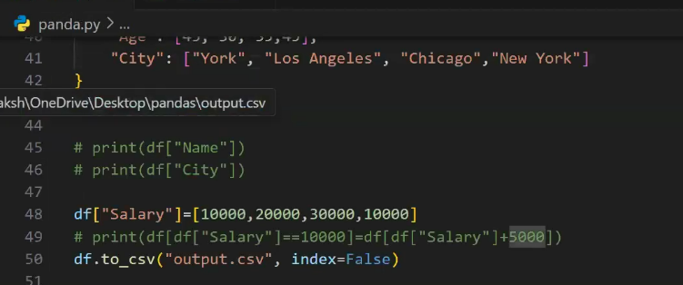

Matplotlib

What is Matplotlib?
- Matplotlib is a low level graph plotting library in python that serves as a visualization utility.
- Matplotlib was created by John D. Hunter.
- Matplotlib is open source and we can use it freely.
- Matplotlib is mostly written in python, a few segments are written in C, Objective-C and Javascript for Platform compatibility.

Installation and Import
Installation makes the Matplotlib package available in the Python environment. pyplot is then commonly imported with the alias plt.
Example
pip install matplotlib
import matplotlib
import matplotlib.pyplot as plt
print(matplotlib.__version__)

Output: The installed Matplotlib version is printed, for example 3.x.x. The exact version depends on the environment.
The supplied reference uses pip install matplotlib and checks the version with matplotlib.__version__.

Pyplot
matplotlib.pyplot is the commonly used Matplotlib module for creating visualizations. It provides functions such as plot(), bar(), hist(), scatter(), pie(), title(), xlabel(), ylabel(), legend(), grid(), show(), and savefig().
Example
import matplotlib.pyplot as plt
x = [1,2,3,4]
y = [10,20,25,30]
plt.plot(x,y)
plt.show()
Output: A line graph is displayed.
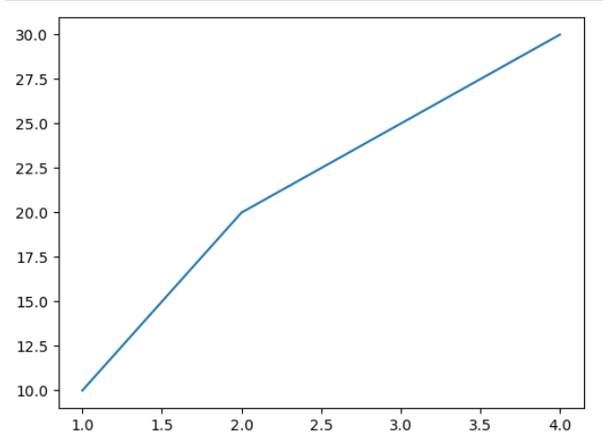
The attached notes describe pyplot as an interface similar to MATLAB and use it for line plots, bar charts, histograms, and scatter plots.

Basic Plot Structure
The basic Matplotlib workflow is: import pyplot → prepare x and y data → call a plotting function → optionally customize → display or save the figure.
Example
import matplotlib.pyplot as plt
x = [1,2,3,4,5]
y = [10,15,8,20,18]
plt.plot(x,y)
plt.show()
Output: Output: A line plot connecting the five data points.
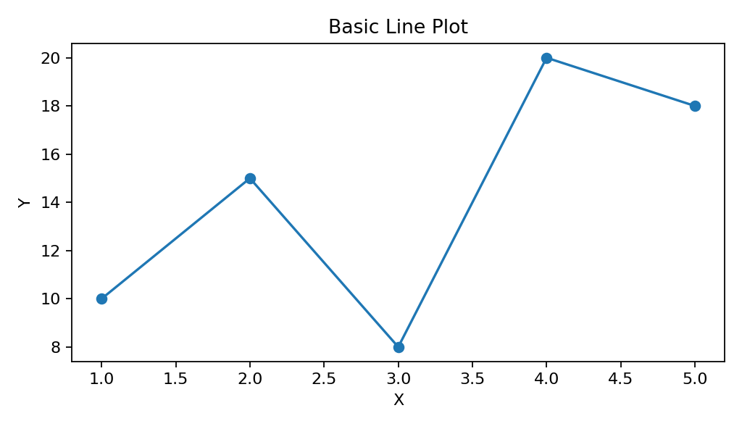

Plotting X and Y Points
plt.plot(x, y) places the x values on the horizontal axis and y values on the vertical axis, then connects corresponding points with a line by default.
Example
x = [5,2,7]
y = [2,16,4]
plt.plot(x,y)
plt.title('Info')
plt.ylabel('Y axis')
plt.xlabel('X axis')
plt.show()
Output: A line graph containing the points (5,2), (2,16), and (7,4), connected in the supplied order.
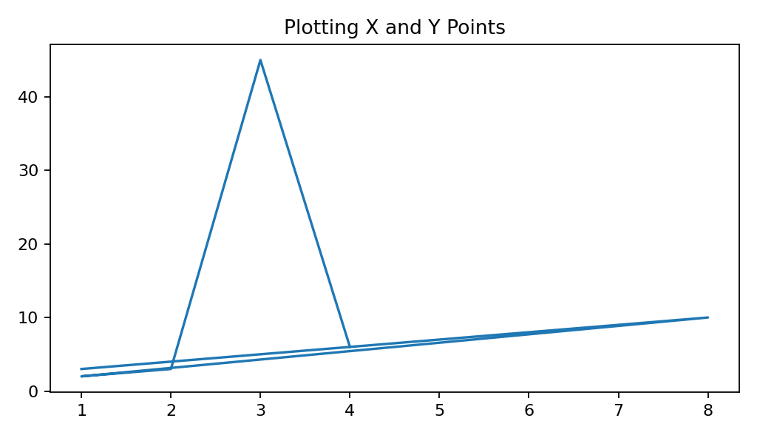

Plotting Points Without a Line
Passing a marker such as 'o' to plot() displays the points without connecting them with a visible line.
Example
xpoints = np.array([1,8])
ypoints = np.array([3,10])
plt.plot(xpoints,ypoints,'o')
plt.show()
Output: Two circular points are displayed with no connecting line.
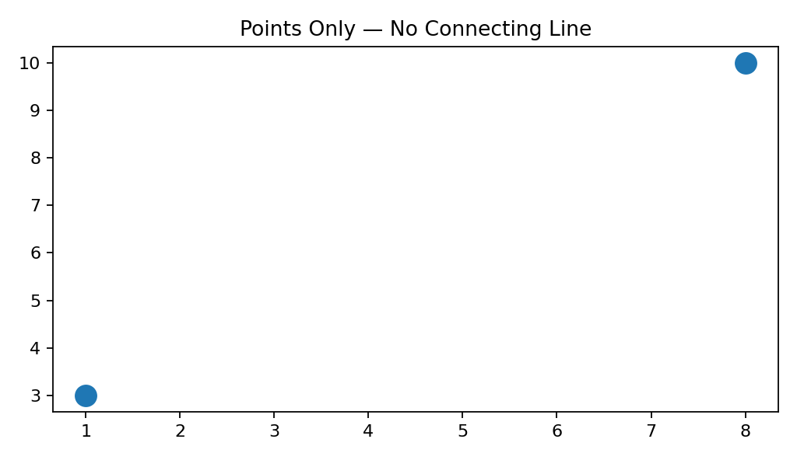

Markers
A marker emphasizes individual data points on a plot. The marker argument controls the symbol used for each point.
Marker | Meaning
o | Circle
* | Star
. | Point
, | Pixel
x | X
X | Filled X
+ | Plus
P | Filled Plus
s | Square
D | Diamond
d | Thin diamond
p | Pentagon
H / h | Hexagon
v / ^ | Triangle down / up
< / > | Triangle left / right
| / _ | Vertical / horizontal line
Example
ypoints = np.array([3,8,1,10])
plt.plot(ypoints, marker='s')
plt.show()
Output: A line plot with square markers.
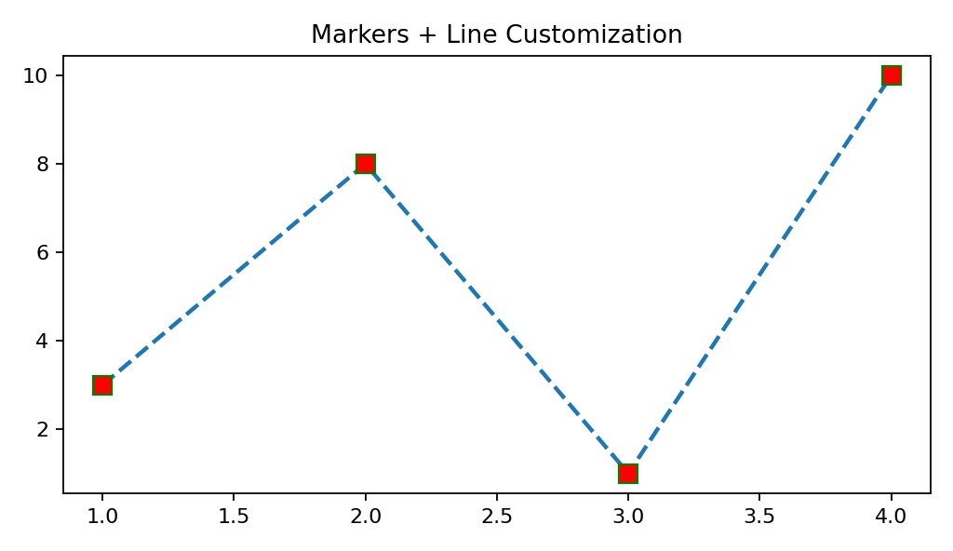

Marker Size
markersize or its short form ms controls the size of markers.
Example
ypoints = np.array([3,8,1,10])
plt.plot(ypoints, marker='o', ms=20)
plt.show()
Output: Large circular markers are displayed.
This follows the supplied reference example using ms=20.

Marker Edge and Face Color
markeredgecolor (mec) controls the marker outline, while markerfacecolor (mfc) controls the inside of the marker.
Example
plt.plot(ypoints, marker='o', ms=20, mec='g', mfc='r')
plt.show()
Output: Large circular markers with a green edge and red face.
The supplied notebook and reference distinguish marker edge and marker face color. fileciteturn5file0L72-L76

Line Color
color or its short form c changes the color of a plotted line.
Example
plt.plot(ypoints, color='g')
plt.show()
Output: A green line plot.
The reference explicitly documents color/c as the line-color parameter. fileciteturn5file0L81-L85

Line Width
linewidth or its short form lw controls the thickness of a line. The supplied notes describe the value as a floating-point number measured in points.
Example
plt.plot(ypoints, linewidth=5)
plt.show()
Output: A thicker line is displayed.

Line Styles
linestyle controls the visual pattern of a line.
Style | Syntax
Solid | '-' / 'solid'
Dotted | : / 'dotted'
Dashed | '--' / 'dashed'
Dash-dot | '-.' / 'dashdot'
No line | '' / ' ' / 'None'
Example
plt.plot(ypoints, linestyle='dashed')
plt.show()
Output: A dashed line plot.

Multiple Lines
Multiple plt.plot() calls can be used to display more than one line in the same axes. Labels can identify each line.
Example
x = [1,2,3,4,5]
y1 = [10,15,8,20,18]
y2 = [5,12,10,15,22]
plt.plot(x,y1,label='Line 1',marker='o')
plt.plot(x,y2,label='Line 2',marker='s',linestyle='--')
plt.legend()
plt.show()
Output: Two lines appear on the same graph with a legend.
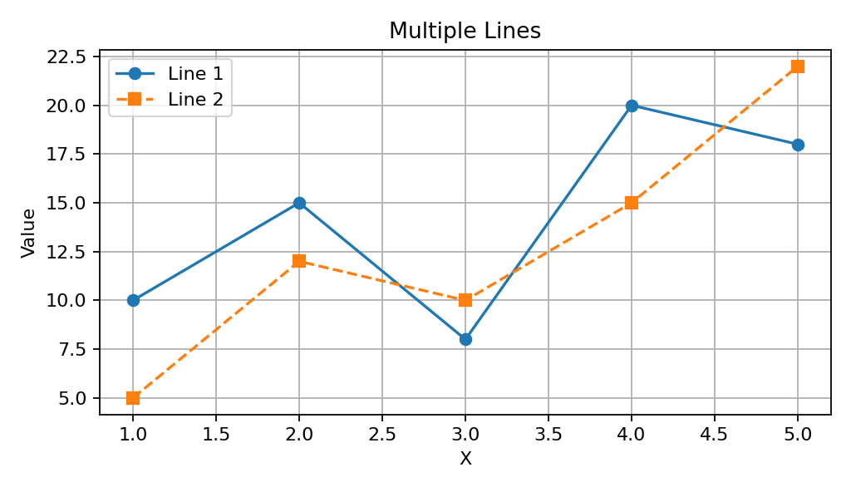

Labels and Title
xlabel() labels the x-axis, ylabel() labels the y-axis, and title() adds a title to the plot. The title() function can also use loc='left', 'center', or 'right' to position the title.
Example
plt.plot(x,y,marker='o',linestyle='--')
plt.xlabel('X-axis Label')
plt.ylabel('Y-axis Label')
plt.title('Line Plot Example')
plt.show()
Output: The graph displays a title and labels on both axes.
The supplied reference documents title positioning and the xlabel()/ylabel() functions. fileciteturn5file0L102-L111

Grid and Legend
grid() adds reference lines to a plot, while legend() displays labels for plotted objects.
Example
plt.plot(x,y,label='Data')
plt.title('Grid and Legend')
plt.xlabel('X')
plt.ylabel('Y')
plt.grid(True)
plt.legend()
plt.show()
Output: A line plot with grid lines and a legend.
grid(axis=...) can target 'x', 'y', or 'both'; the supplied reference gives 'both' as the default. fileciteturn5file0L116-L128

Axis Limits and Ticks
xlim() and ylim() control visible axis ranges. xticks() and yticks() control tick positions and, when supplied with labels, can replace the displayed tick labels.
Example
plt.plot(x,y)
plt.xlim(0,6)
plt.ylim(0,25)
plt.xticks([1,2,3,4,5])
plt.yticks([0,5,10,15,20,25])
plt.grid(True)
plt.show()
Output: The graph uses the specified x/y ranges and tick positions.
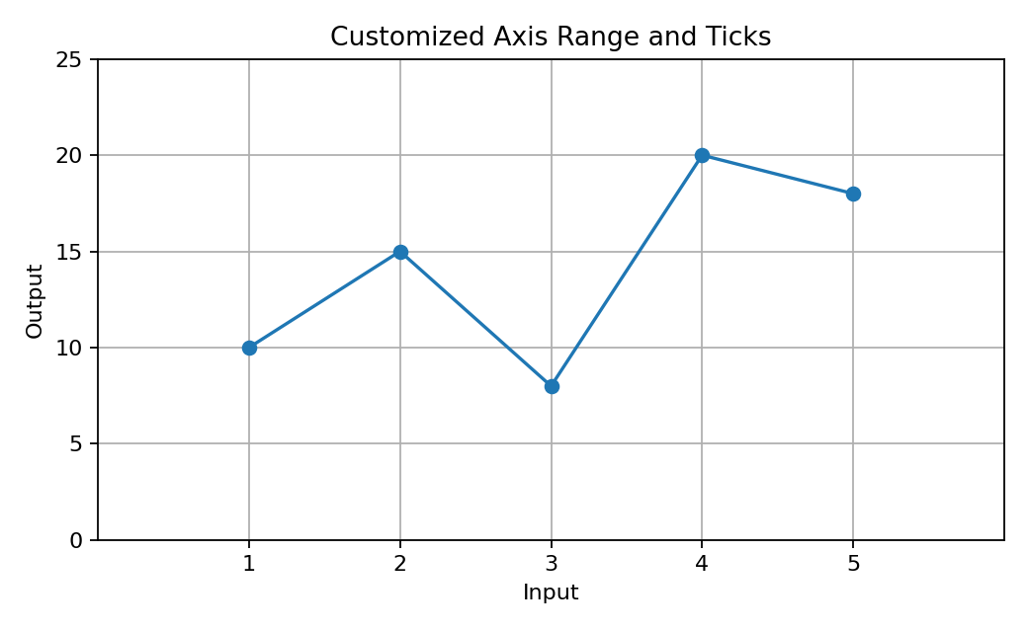

Figure Size
figsize controls the size of a Matplotlib figure, normally specified as (width, height) in inches.
Example
plt.figure(figsize=(8,5))
plt.plot(x,y)
plt.show()
Output: A larger 8 × 5 inch figure is displayed.
The supplied notes use plt.figure(figsize=(8,5)).

Subplots
Subplots place multiple axes/plots inside a single figure. subplot(rows, columns, index) selects a position in a grid.
Example
import matplotlib.pyplot as plt
import numpy as np

x = np.array([0, 1, 2, 3])
y = np.array([3, 8, 1, 10])

plt.subplot(2, 3, 1)
plt.plot(x,y)

x = np.array([0, 1, 2, 3])
y = np.array([10, 20, 30, 40])

plt.subplot(2, 3, 2)
plt.plot(x,y)

x = np.array([0, 1, 2, 3])
y = np.array([3, 8, 1, 10])

plt.subplot(2, 3, 3)
plt.plot(x,y)

x = np.array([0, 1, 2, 3])
y = np.array([10, 20, 30, 40])

plt.subplot(2, 3, 4)
plt.plot(x,y)

x = np.array([0, 1, 2, 3])
y = np.array([3, 8, 1, 10])

plt.subplot(2, 3, 5)
plt.plot(x,y)

x = np.array([0, 1, 2, 3])
y = np.array([10, 20, 30, 40])

plt.subplot(2, 3, 6)
plt.plot(x,y)

plt.show()

Output: Two plots are displayed side-by-side in one figure.
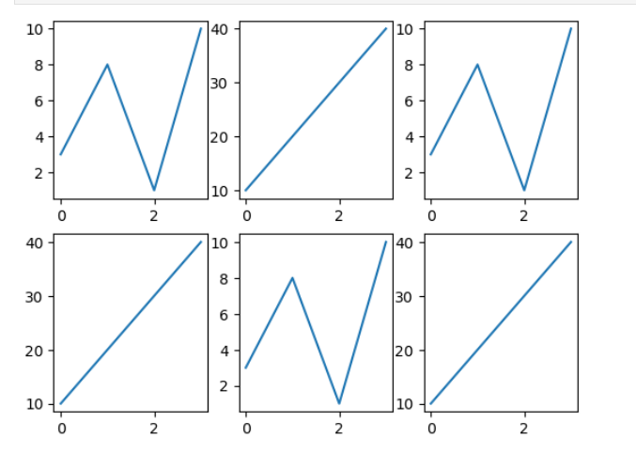
The reference explains that subplot() uses rows, columns, and the current plot index; it also presents plt.subplots() as the better approach for multiple plots.

Line Plot
A line plot displays ordered observations connected by lines and is commonly used to show trends.
Example
plt.plot(x,y,marker='o',linestyle='-',color='blue')
plt.show()
Output: A line chart showing the change in y across x.
The supplied notes identify line plots as useful for trends.

Bar Chart — Vertical and Horizontal
A bar chart compares categorical values. bar() creates vertical bars, while barh() creates horizontal bars. width controls vertical-bar width; height controls horizontal-bar height.
Example
categories = ['A','B','C','D']
values = [5,7,3,8]
plt.bar(categories,values)
plt.show()
Output: Four vertical bars; D has the highest value.
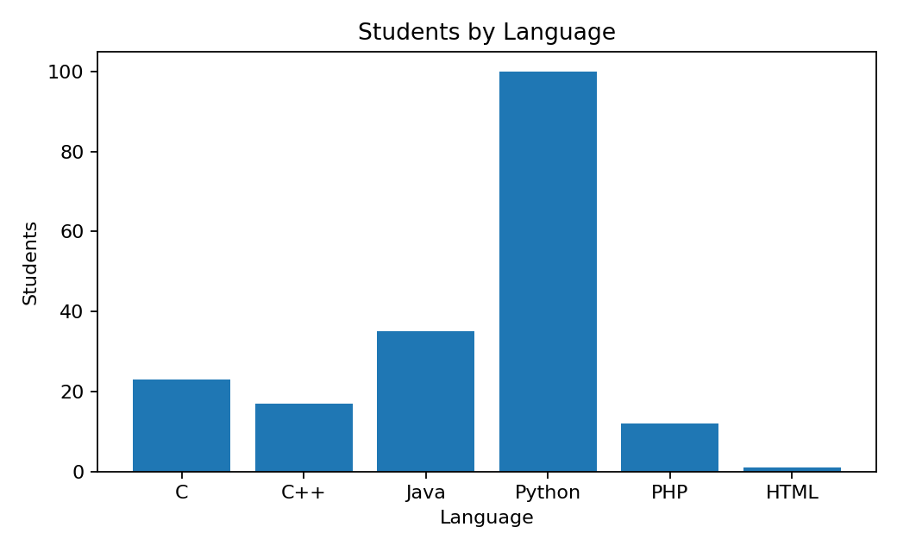
Example
activities = ['sports','phone','friends','money','online','club','TV']
frequency = [45,53,99,44,66,22,37]
plt.barh(activities,frequency)
plt.show()
Output: Horizontal bars comparing student activities.
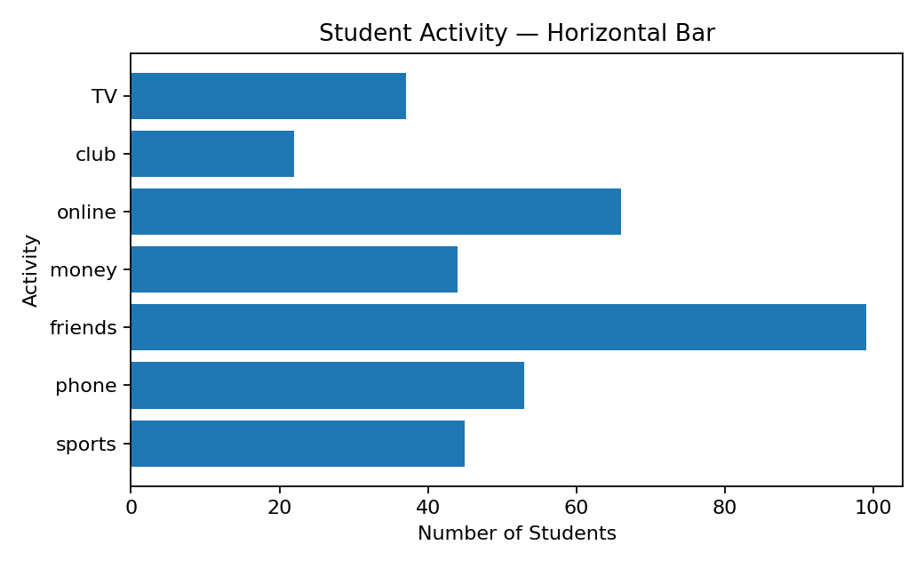
The reference documents bar(), barh(), width, and height.

Grouped Bar Chart
A grouped bar chart places multiple bars side-by-side for each category so that two or more series can be compared.
Example
x = np.arange(5)
width = 0.35
plt.bar(x-width/2,[50,40,70,80,20],width,label='BMW')
plt.bar(x+width/2,[80,20,20,50,60],width,label='Audi')
plt.legend()
plt.show()
Output: Two bars are shown for each day/category, making the two series directly comparable.
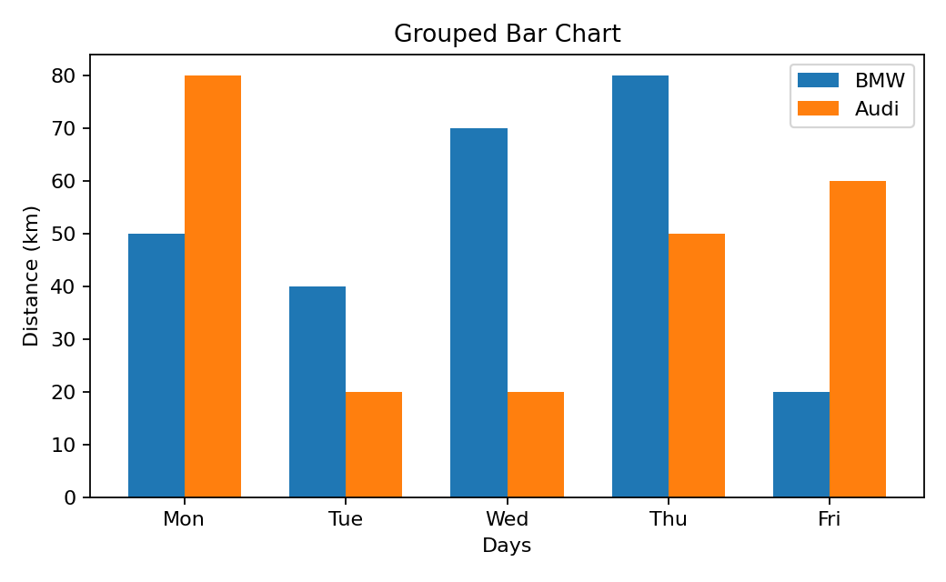

23. Histogram and Bins
A histogram shows a frequency distribution by counting observations within intervals called bins. Unlike a bar chart, which compares separate categories, a histogram groups numeric values into ranges.
Example
a = np.array([22,87,5,43,56,73,55,54,11,20,51,5,79,31,27])
plt.hist(a,bins=[0,25,50,75,100])
plt.xlabel('Marks')
plt.ylabel('No. of Students')
plt.show()
Output: Frequency bars for the ranges 0–25, 25–50, 50–75, and 75–100.
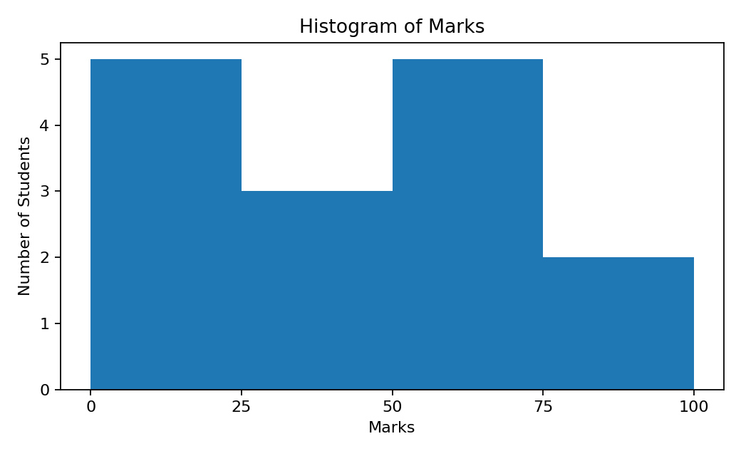
The supplied notebook explicitly explains bins as ranges/intervals and distinguishes histograms (distribution) from bar charts (comparison).

Pie Chart
A pie chart is a circular graph divided into slices. It is commonly used to represent percentages or proportions of a whole.
Example
data = [1433783686, 1366417754, 329064917, 270625568, 216565318 ]
l = ['China', 'India', 'United States', 'Indonesia', 'Pakistan', ]
e = [0.7, 0.0, 0.0, 0.0, 0.5]
colors = ['#ccffcc', 'orange', 'blue', 'green','#333300']

plt.pie(data, labels=l, explode=e, shadow=True, startangle=180,
wedgeprops={'edgecolor':'black', 'linewidth': 6 },colors=colors)

plt.title("Population Pie Chart")
plt.show()

Output: Output: A pie chart showing the percentage share of each category, with Python slightly separated.
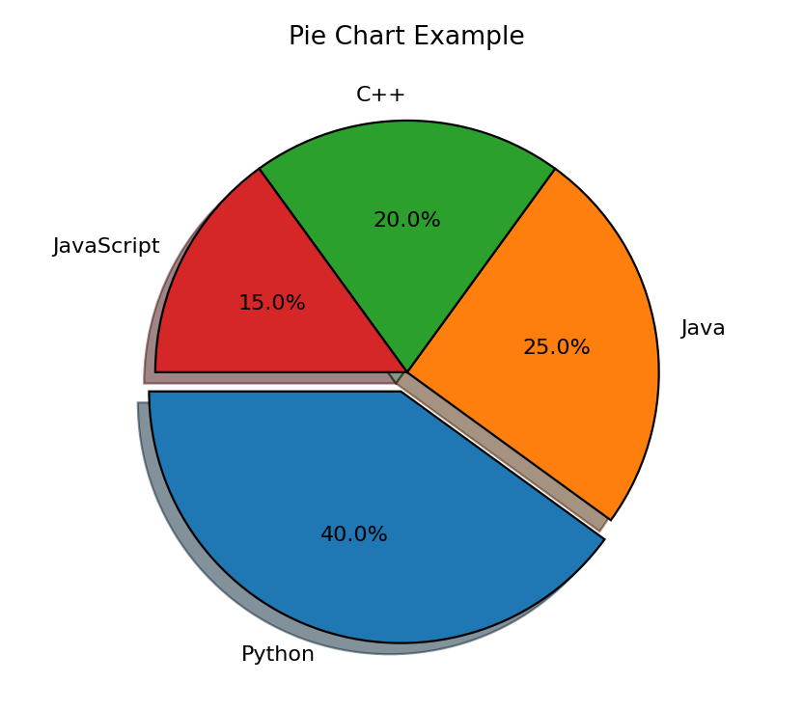
- labels → names each wedge.
- autopct → displays percentages.
- explode → separates selected wedges.
- shadow → adds a shadow effect.
- legend() → can provide an explanatory legend.
These pie-chart parameters are explicitly covered in the supplied reference.

Scatter Plot
A scatter plot represents observations as individual points and is commonly used to investigate a relationship between two variables. The x value controls horizontal position and the y value controls vertical position.
Example
students_id = [1,2,3,4,5,6,7,8,9,10]
students_marks = [95,98,83,75,67,58,67,78,53,32]
plt.scatter(students_id,students_marks)
plt.xlabel('Student ID')
plt.ylabel('Marks')
plt.show()
Output: One point for each student, positioned according to ID and marks.
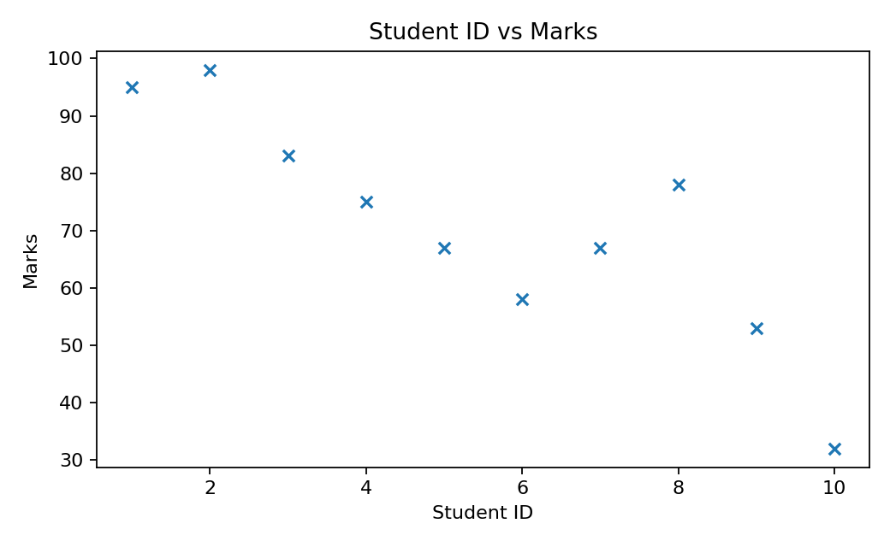
The supplied reference states that scatter() requires x and y arrays of the same length and documents s for point size and alpha for transparency.

Box Plot
A box plot summarizes the distribution of numeric data and is useful for examining the median, spread, quartiles, and potential outliers.
Example
values = [0,1,50,60,50,14,909,1000,101]
plt.boxplot(values)
plt.title('Box Plot')
plt.ylabel('Value')
plt.show()
Output: A box-and-whisker plot highlighting the central distribution and unusually large values.
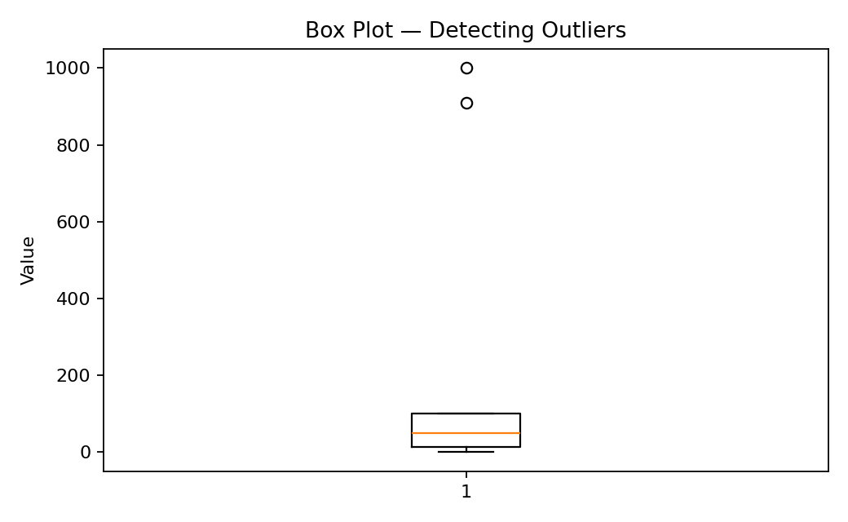
The supplied Matplotlib.ipynb describes box plots as a combination of distribution ideas and explicitly says they are used to find outliers. Its practical cell uses Seaborn for the boxplot; this documentation shows the equivalent native Matplotlib boxplot().

Heatmap-style Visualization
A heatmap-style visualization represents matrix values using different visual intensities. Matplotlib can create a heatmap-like display with imshow() and a colorbar. The supplied notebook demonstrates a heatmap using Seaborn's heatmap() function.
Example
data = np.arange(1,101).reshape(10,10)
plt.imshow(data,aspect='auto')
plt.colorbar(label='Value')
plt.title('Heatmap-style Matrix')
plt.show()
Output: A matrix displayed as a color-coded grid with a value scale.
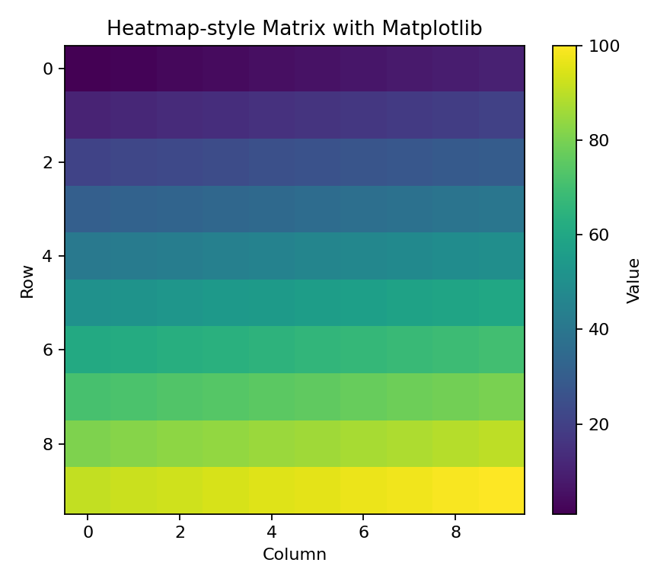
Source note: the attached notebook's actual heatmap example imports Seaborn and calls sn.heatmap(data=data). This section keeps that source distinction instead of presenting Seaborn's function as a Matplotlib function.

Figure, Axes and Backend
Figure is the whole chart area/container. Axes is the actual plotting area where data is drawn. Backend is the engine responsible for displaying/rendering plots in an environment such as Jupyter or a GUI.
Concept | Meaning
Figure | Whole chart area / container
Axes | Actual plotting area
Backend | Rendering/display engine used by the environment
The supplied notes explicitly define Figure, Axes, and Backend in these terms.

Common Matplotlib Functions
Matplotlib provides plotting, figure/axes control, text, axis control, styling, and display/saving functions.
Category | Functions | Purpose
Plotting | plot(), bar(), barh(), hist(), scatter(), pie() | Create common charts
Additional plotting | boxplot(), violinplot(), stackplot(), step(), fill_between(), errorbar() | Specialized visualizations
Figure & axes | figure(), subplots(), subplot(), gca(), gcf(), axes() | Create/access figure and axes
Labels & text | title(), xlabel(), ylabel(), legend(), text(), annotate() | Add explanations and labels
Axis control | xlim(), ylim(), xticks(), yticks(), axis(), grid() | Control ranges/ticks/grid
Styling | style.use(), rcParams, setp() | Set styles and properties
Display/save | show(), savefig(), close() | Display, save, and close figures
This list is compiled directly from the supplied Matplotlib Notes function lists.

Saving, Displaying and Closing Figures
show() displays the plot, savefig() saves the current figure to a file, and close() closes a figure.
Example
plt.plot(x,y)
plt.savefig('chart.png')
plt.show()
plt.close()
Output: chart.png is created, the plot is displayed, and the figure is then closed.
The supplied notes explicitly cover show(), savefig(), and close().

Real Dataset Example — richest.csv
Example:
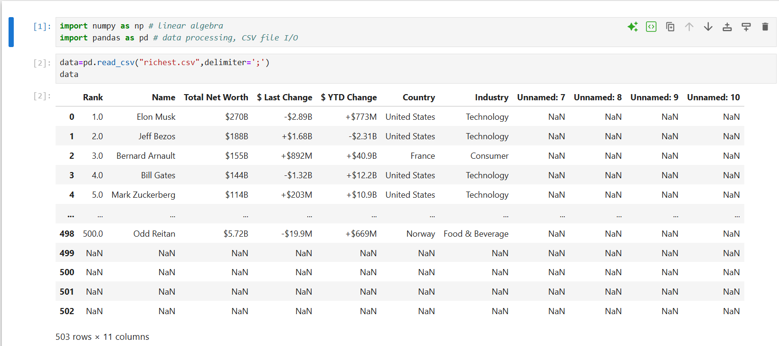
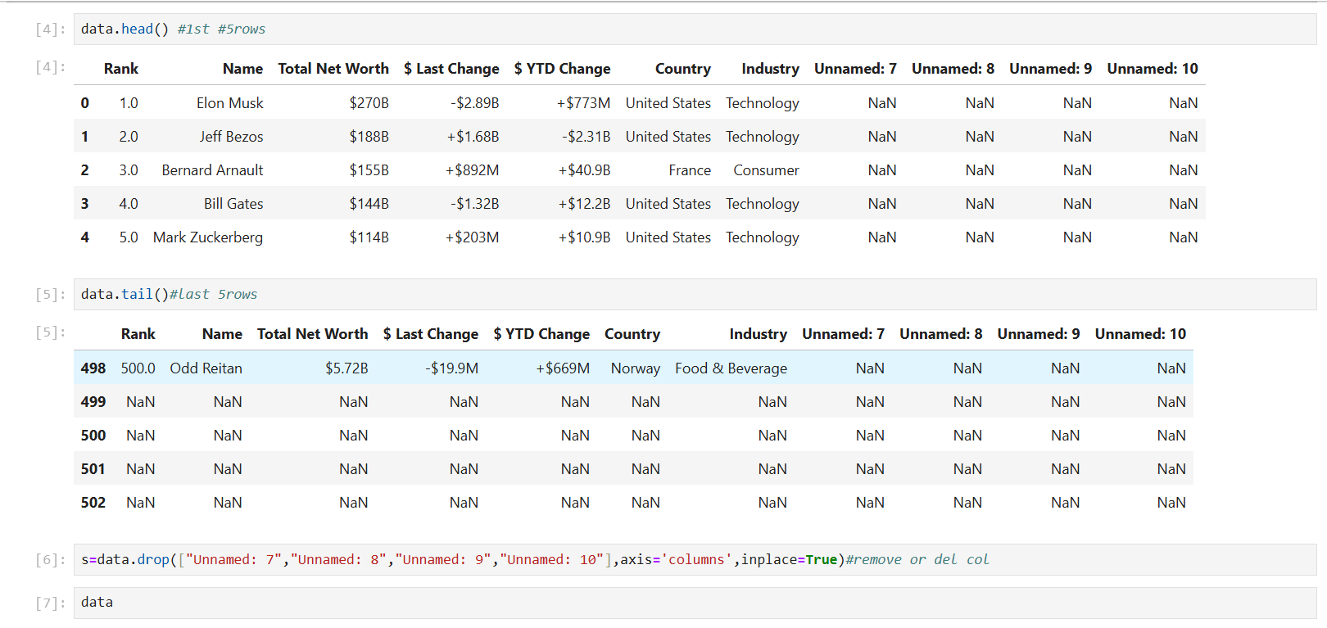

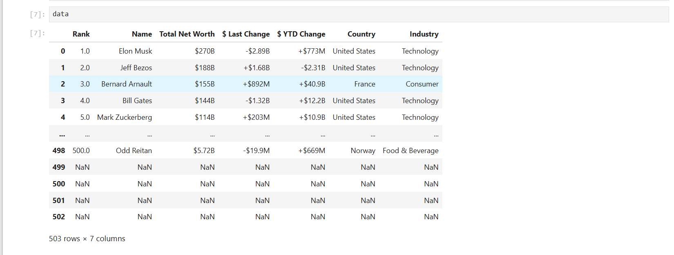
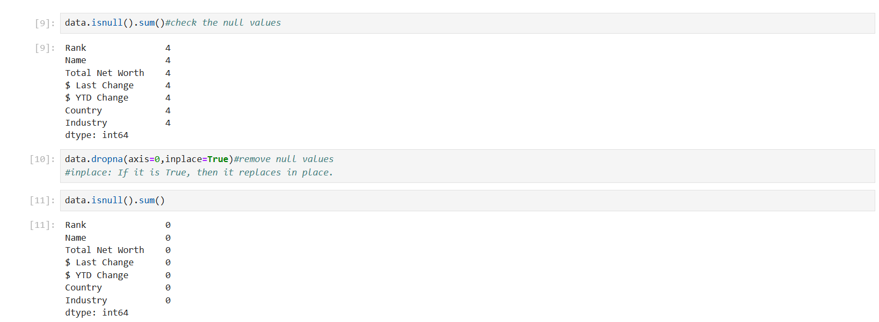
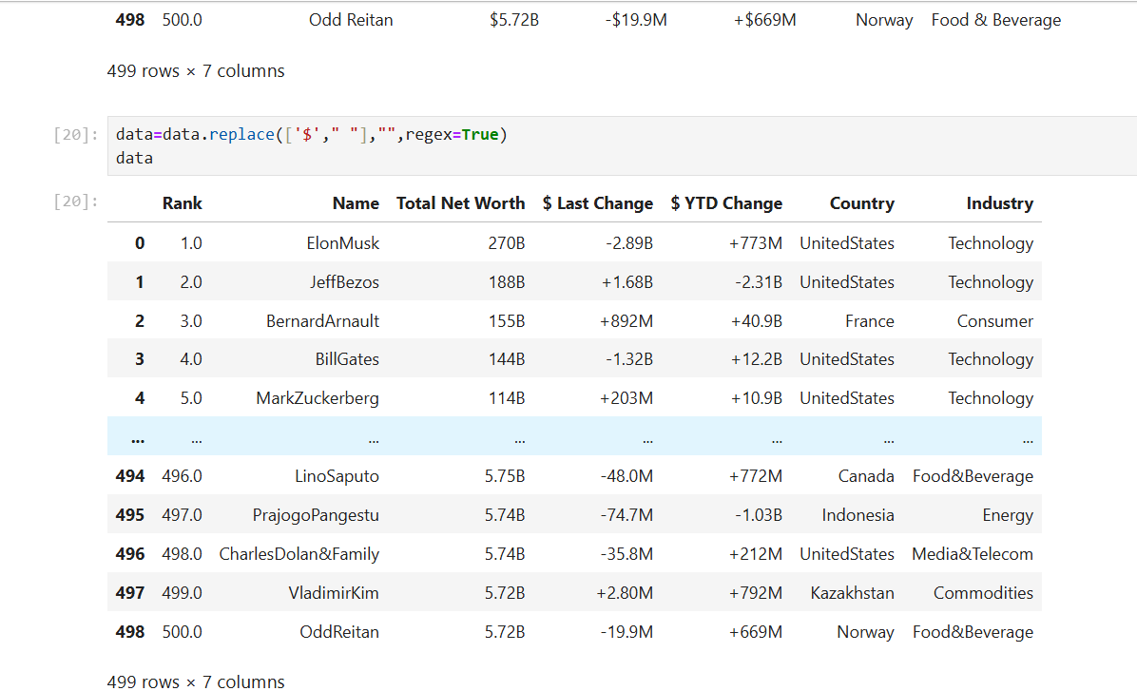

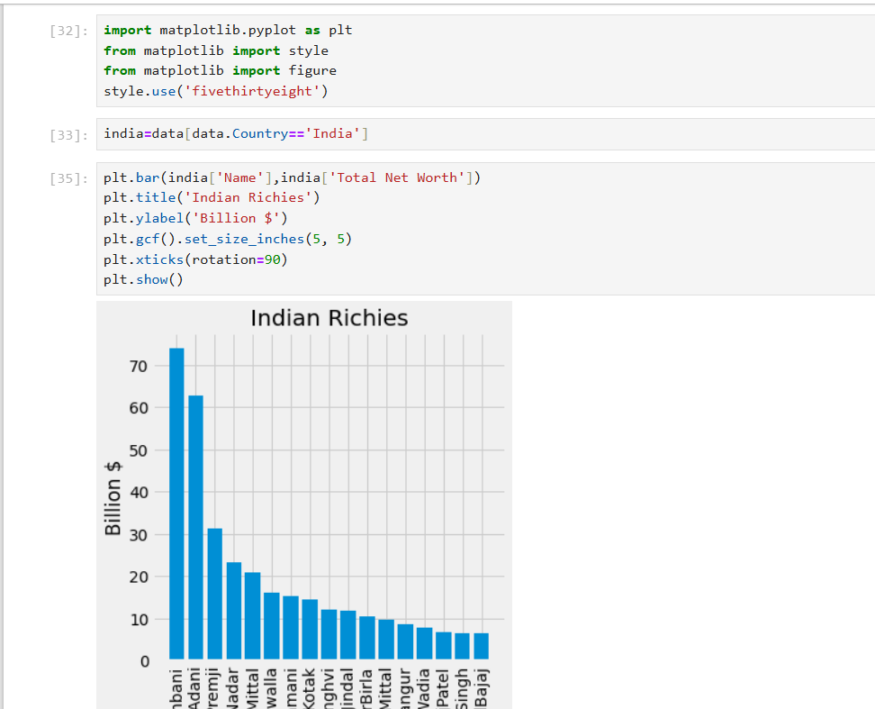

OS Module in Python 🖥️
Python has a built-in os module with methods for interacting with the operating system, like creating files and directories, management of files and directories, input, output, environment variables, process management, etc.

1. Importing the OS Module
import os

2. Working with the File System
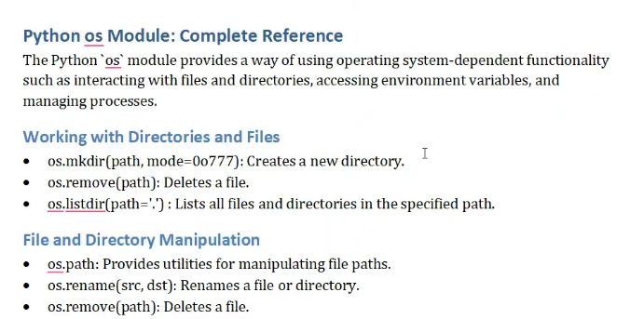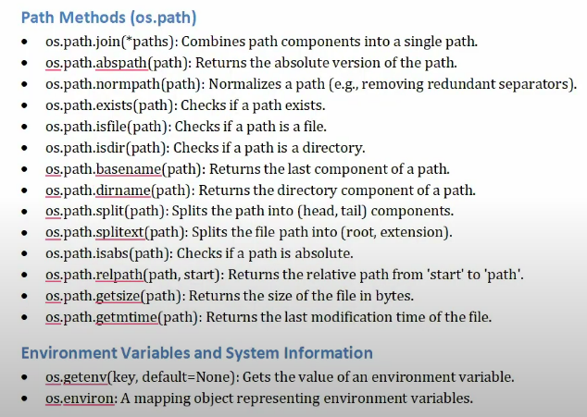
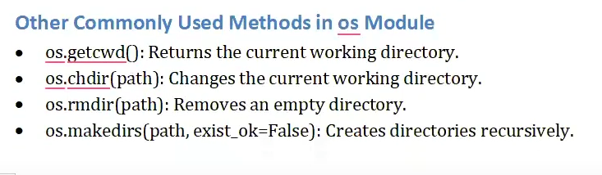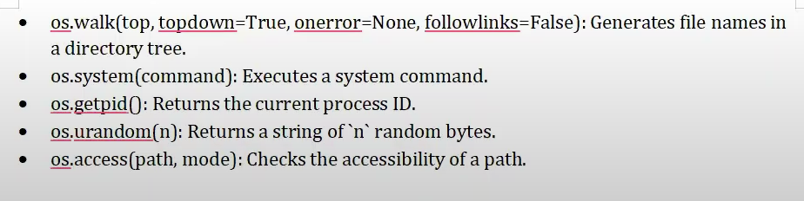

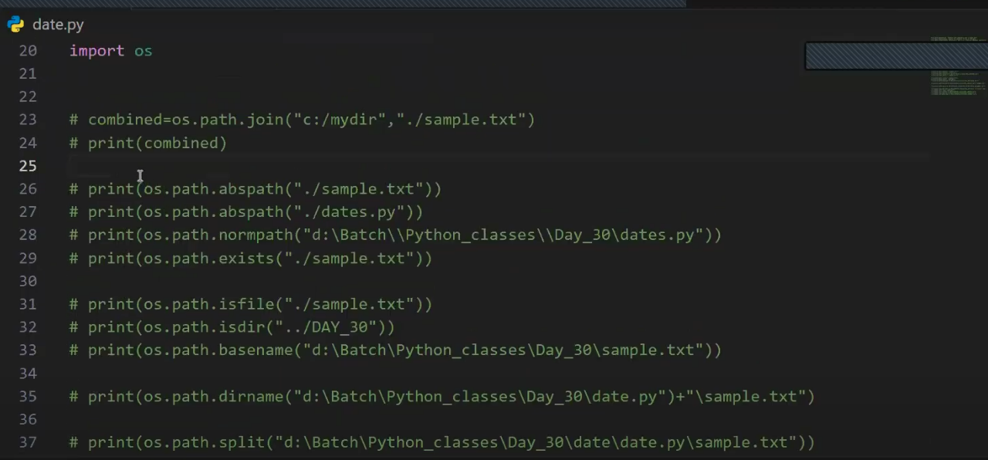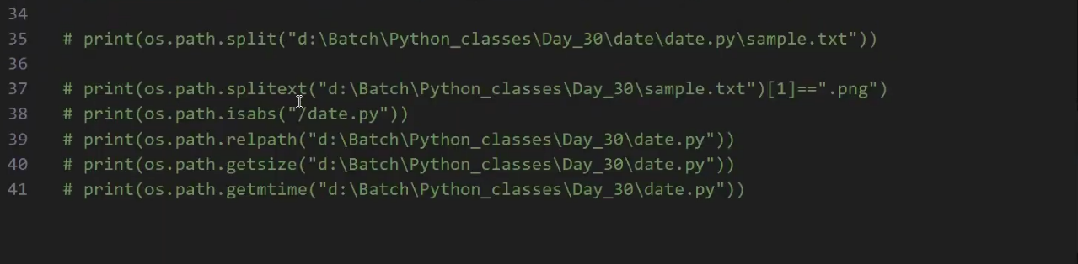

Database connection
Why We Use Database Connection in Python
Python is a powerful programming language, but it doesn’t store data permanently by itself. That’s where databases come in!
When you connect Python to a database, you can:
✅ Store data permanently
Example: Save user registration details, product listings, student records, etc.

✅ Retrieve data later
Example: Load data from a table to display in a web app or desktop app.

✅ Manage large volumes of structured data
Databases like MySQL, PostgreSQL, or SQLite handle thousands (or millions) of records efficiently.

🎯 Real-Life Examples
Use Case | How Python + DB helps
Login/Signup system | Store usernames and passwords securely
E-commerce app | Manage product listings, orders, inventory
School management system | Track students, marks, attendance
Employee records | HR systems use databases to store details
Data analysis projects | Fetch real-time data for analysis or reports

Common Databases You Can Use with Python
DBMS | Python Library
MySQL | mysql-connector-python
PostgreSQL | psycopg2
SQLite | sqlite3 (built-in)
MongoDB | pymongo
Oracle | cx_Oracle

🔗 What is a Database Connection?
A database connection is a bridge between your Python program and a database (like MySQL, SQLite, PostgreSQL, etc.). It allows your Python code to talk to the database to:
- Save data
- Read data
- Update data
- Delete data

🧱 Components of a Database Connection
When you connect to a database, you typically need:
Component | Description
Host | The server where the database is running (localhost for local)
User | The username to access the database
Password | The password for that user
Database | The specific database you want to work with
Port | Communication port (default for MySQL: 3306)

Steps to Connect Python to a Database
Here’s a typical process using MySQL:

1. Install the connector:
pip install mysql-connector-python

2. Import and Connect
import mysql.connector

connection = mysql.connector.connect(
host="localhost",
user="root",
password="your_password",
database="your_db"
)

3. Create a Cursor Object
cursor = connection.cursor()

4. Execute SQL Queries
cursor.execute("SELECT * FROM students")
results = cursor.fetchall()
for row in results:
print(row)

5. Commit Changes (if needed)
connection.commit()

6. Close Connection
cursor.close()
connection.close()

Features & Advantages
Feature |  | Why it’s Important
🔄 CRUD Support |  | Add, edit, delete, and read data easily
📁 Data Persistence |  | Data doesn’t disappear when program ends
⚡ Efficient |  | Databases handle large data faster than files
🔐 Secure Access |  | Controlled access using users and roles
📊 Integration |  | Works great with data tools and dashboards
🧠 SQL Power |  | Use powerful queries for filtering, joins, etc.

Database Connection

import mysql.connector

connection=mysql.connector.connect(
host="localhost",
user="root",
password="root",
database="py_connection"
)

if connection.is_connected():
print("connected to mysql")

connection.close()

CURD Operations:

- Creation of Table
import mysql.connector
from mysql.connector import Error

try:
connection=mysql.connector.connect(
host="localhost",
user="root",
password="root",
database="py_connection"
)

if connection.is_connected():
print("connected to mysql")

cursor = connection.cursor()

# cursor.execute("SHOW DATABASES") # Show all databases
# for db in cursor:
# print(db)

cursor.execute("""
CREATE TABLE IF NOT EXISTS student1 (
id INT AUTO_INCREMENT PRIMARY KEY,
name VARCHAR(255),
age INT
)
""")

connection.commit()

except Error as e:
print("error at connection ",e)

finally:
if connection:
cursor.close()
connection.close()

- Inserting Data

import mysql.connector
from mysql.connector import Error

try:
connection=mysql.connector.connect(
host="localhost",
user="root",
password="root",
database="py_connection"
)

if connection.is_connected():
print("connected to mysql")

cursor = connection.cursor()

# cursor.execute("SHOW DATABASES") # Show all databases
# for db in cursor:
# print(db)

cursor.execute("INSERT INTO students (name, age) VALUES (%s, %s)", ("John", 20))

sql = "INSERT INTO students (name, age) VALUES (%s, %s)"
val = ("Alice", 22)
cursor.execute(sql,val)

connection.commit()
print("Data entered")

except Error as e:
print("error at connection ",e)

finally:
if connection:
cursor.close()
connection.close()

- Modifying /Updating Data

cursor = connection.cursor()
# Update a record
update_sql = "UPDATE students SET age = %s WHERE name = %s"
update_val = (23, "Alice")
cursor.execute(update_sql, update_val)

connection.commit()
print(" Record updated successfully")

- Removing Single record

cursor = connection.cursor()

# DELETE a record where name is 'John'
delete_sql = "DELETE FROM students WHERE name = %s"
delete_val = ("John",)
cursor.execute(delete_sql, delete_val)

connection.commit()
print(" Record deleted successfully")

- Removing all records

cursor = connection.cursor()

# DELETE all records
cursor.execute("DELETE FROM students")
connection.commit()

print(" Record deleted successfully")

Data Fetching/ Display Table Data

cursor = connection.cursor()

# cursor.execute("select * from students")
# print(cursor.fetchall())

cursor.execute("select * from students")
result=cursor.fetchall()

for row in result:
print(row)

Login/Signup System using Python + MySQL

Project Overview
A console-based application with:
- ✅ Signup – Save new users to the database.
- 🔐 Login – Verify user credentials.
- ❌ Exit – Exit the app.

Database Setup (MySQL): First, open MySQL and run

CREATE DATABASE user_auth;

USE user_auth;

CREATE TABLE users (
id INT AUTO_INCREMENT PRIMARY KEY,
username VARCHAR(100) UNIQUE NOT NULL,
password VARCHAR(255) NOT NULL
);

Python Script (login_signup.py)
Here’s a basic working code:

import mysql.connector
from mysql.connector import Error

try:
# Connect to database
mydb = mysql.connector.connect(
host="localhost",
user="root",
password="root",
database="py_connection"
)

cursor = mydb.cursor()

# Signup function
def signup():
username = input("Enter a new username: ")
password = input("Enter a new password: ")

try:
cursor.execute("INSERT INTO users (username, password) VALUES (%s, %s)", (username, password))
mydb.commit()
print("✅ Signup successful!")
except mysql.connector.IntegrityError:
print("❗ Username already exists. Try a different one.")

# Login function
def login():
username = input("Enter your username: ")
password = input("Enter your password: ")

cursor.execute("SELECT * FROM users WHERE username = %s AND password = %s", (username, password))
result = cursor.fetchone()

if result:
print("🔓 Login successful! Welcome,", username)
else:
print("❌ Invalid credentials. Try again.")

# Menu
while True:
print("\n===== Login/Signup System =====")
print("1. Signup")
print("2. Login")
print("3. Exit")

choice = input("Choose an option: ")

if choice == "1":
signup()
elif choice == "2":
login()
elif choice == "3":
print("👋 Goodbye!")
break
else:
print("❗ Invalid choice. Try again.")

except Error as e:
print("error at connection ",e)

finally:
if mydb:
cursor.close()
mydb.close()

Output:
